UK Standards for Microbiology Investigations

Investigation of specimens for ectoparasites

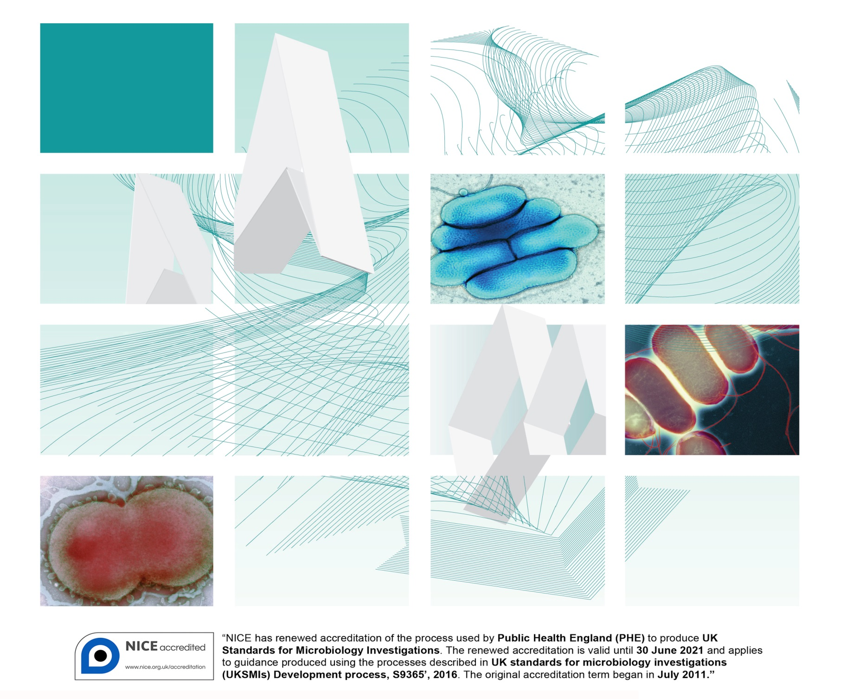

Acknowledgments

UK Standards for Microbiology Investigations (UK SMIs) are developed under the auspices of Public Health England (PHE) working in partnership with the National Health Service (NHS), Public Health Wales and with the professional organisations whose logos are displayed below and listed on the website [https://www.gov.uk/uk-standards-for-microbiology-investigations-smi-quality-and-consistency-in-clinical-laboratories](https://www.gov.uk/uk-standards-for-microbiology-investigations-SMI-quality-and-consistency-in-clinical-laboratories). UK SMIs are developed, reviewed and revised by various working groups which are overseen by a steering committee (see <https://www.gov.uk/government/groups/standards-for-microbiology-investigations-steering-committee>).

The contributions of many individuals in clinical, specialist and reference laboratories who have provided information and comments during the development of this document are acknowledged. We are grateful to the medical editors for editing the medical content.

For further information please contact us at:

Standards Unit

National Infection Service

Public Health England

61 Colindale Avenue

London NW9 5EQ

E-mail: [standards@phe.gov.uk](mailto:standards@phe.gov.uk)

Website: [https://www.gov.uk/uk-standards-for-microbiology-investigations-smi-quality-and-consistency-in-clinical-laboratories](https://www.gov.uk/uk-standards-for-microbiology-investigations-SMI-quality-and-consistency-in-clinical-laboratories)

UK Standards for Microbiology Investigations are produced in association with:



Logos correct at time of publishing.

Contents

Acknowledgments 2

Amendment table 4

UK SMI: scope and purpose 6

Scope of document 9

Key recommendations 9

Introduction 9

Technical information/limitations 51

1 Safety considerations 53

2 Specimen collection 54

3 Specimen transport, storage and retention 55

4 Specimen processing/procedure 55

5 Reporting procedure 57

6 Notification to PHE, or equivalent in the devolved administrations 57

References 59



Amendment table

Each UK SMI method has an individual record of amendments. The current amendments are listed on this page. The amendment history is available from [standards@phe.gov.uk](mailto:standards@phe.gov.uk).

New or revised documents should be controlled within the laboratory in accordance with the local quality management system.

|  |  |
| --- | --- |
| Amendment number/date | 8/12.10.18 |
| Issue number discarded | 2.1 |
| Insert issue number | 2.2 |
| Anticipated next review date* | 27.04.18 |
| Section(s) involved | Amendment |
| Whole document. | References have been converted from Reference Manager to Endnote. |

|  |  |
| --- | --- |
| Amendment number/date | 7/27.10.16 |
| Issue number discarded | 2 |
| Insert issue number | 2.1 |
| Anticipated next review date* | 27.04.18 |
| **Section(s) involved** | **Amendment** |
| Whole document. | B 61 formerly G 9.  Document presented in a new format. |

|  |  |
| --- | --- |
| Amendment number/date | 6/27.04.15 |
| Issue number discarded | 1.4 |
| Insert issue number | 2 |
| **Section(s) involved** | **Amendment** |
| Whole document. | Hyperlinks updated to gov.uk. |
| Page 2. | Updated logos added. |
| Introduction. | Minor text changes for clarity. Minor grammatical corrections. |
| Section 3 – fleas. | Photographs and illustrations of *Ctenocephalides canis* updated.  Information regarding *Ceratophyllus* and *Nasophyllus* species expanded. |
| Section 4 – lice. | Addition of illustration of female *Pediculus humanus.* |
| Section 5 – bedbugs. | Photographs and illustrations of *Cimex lectularis* updated. |
| Section 10 - laboratory procedures. | Under section 10.1 Safety Considerations – addition of text regarding processing of samples where Hazard Group 3 organisms are suspected. |
| References. | Some references updated. |

*Reviews can be extended up to five years subject to resources available.

UK SMI[1]#: scope and purpose

Users of UK SMIs

Primarily, UK SMIs are intended as a general resource for practising professionals operating in the field of laboratory medicine and infection specialties in the UK. UK SMIs also provide clinicians with information about the available test repertoire and the standard of laboratory services they should expect for the investigation of infection in their patients, as well as providing information that aids the electronic ordering of appropriate tests. The documents also provide commissioners of healthcare services with the appropriateness and standard of microbiology investigations they should be seeking as part of the clinical and public health care package for their population.

Background to UK SMIs

UK SMIs comprise a collection of recommended algorithms and procedures covering all stages of the investigative process in microbiology from the pre-analytical (clinical syndrome) stage to the analytical (laboratory testing) and post analytical (result interpretation and reporting) stages. Syndromic algorithms are supported by more detailed documents containing advice on the investigation of specific diseases and infections. Guidance notes cover the clinical background, differential diagnosis, and appropriate investigation of particular clinical conditions. Quality guidance notes describe laboratory processes which underpin quality, for example assay validation.

Standardisation of the diagnostic process through the application of UK SMIs helps to assure the equivalence of investigation strategies in different laboratories across the UK and is essential for public health surveillance, research and development activities.

Equal partnership working

UK SMIs are developed in equal partnership with PHE, NHS, Royal College of Pathologists and professional societies. The list of participating societies may be found at <https://www.gov.uk/uk-standards-for-microbiology-investigations-smi-quality-and-consistency-in-clinical-laboratories>. Inclusion of a logo in an UK SMI indicates participation of the society in equal partnership and support for the objectives and process of preparing UK SMIs. Nominees of professional societies are members of the Steering Committee and working groups which develop UK SMIs. The views of nominees cannot be rigorously representative of the members of their nominating organisations nor the corporate views of their organisations. Nominees act as a conduit for two way reporting and dialogue. Representative views are sought through the consultation process. UK SMIs are developed, reviewed and updated through a wide consultation process.

Quality assurance

NICE has accredited the process used by the UK SMI working groups to produce UK SMIs. The accreditation is applicable to all guidance produced since October 2009. The process for the development of UK SMIs is certified to ISO 9001:2008. UK SMIs represent a good standard of practice to which all clinical and public health microbiology laboratories in the UK are expected to work. UK SMIs are NICE accredited and represent neither minimum standards of practice nor the highest level of complex laboratory investigation possible. In using UK SMIs, laboratories should take account of local requirements and undertake additional investigations where appropriate. UK SMIs help laboratories to meet accreditation requirements by promoting high quality practices which are auditable. UK SMIs also provide a reference point for method development. The performance of UK SMIs depends on competent staff and appropriate quality reagents and equipment. Laboratories should ensure that all commercial and in-house tests have been validated and shown to be fit for purpose. Laboratories should participate in external quality assessment schemes and undertake relevant internal quality control procedures.

Patient and public involvement

The UK SMI working groups are committed to patient and public involvement in the development of UK SMIs. By involving the public, health professionals, scientists and voluntary organisations the resulting UK SMI will be robust and meet the needs of the user. An opportunity is given to members of the public to contribute to consultations through our open access website.

Information governance and equality

PHE is a Caldicott compliant organisation. It seeks to take every possible precaution to prevent unauthorised disclosure of patient details and to ensure that patient-related records are kept under secure conditions. The development of UK SMIs is subject to PHE Equality objectives <https://www.gov.uk/government/organisations/public-health-england/about/equality-and-diversity>.

The UK SMI working groups are committed to achieving the equality objectives by effective consultation with members of the public, partners, stakeholders and specialist interest groups.

Legal statement

While every care has been taken in the preparation of UK SMIs, PHE and the partner organisations, shall, to the greatest extent possible under any applicable law, exclude liability for all losses, costs, claims, damages or expenses arising out of or connected with the use of an UK SMI or any information contained therein. If alterations are made by an end user to an UK SMI for local use, it must be made clear where in the document the alterations have been made and by whom such alterations have been made and also acknowledged that PHE and the partner organisations shall bear no liability for such alterations. For the further avoidance of doubt, as UK SMIs have been developed for application within the UK, any application outside the UK shall be at the user’s risk.

The evidence base and microbial taxonomy for the UK SMI is as complete as possible at the date of issue. Any omissions and new material will be considered at the next review. These standards can only be superseded by revisions of the standard, legislative action, or by NICE accredited guidance.

UK SMIs are Crown copyright which should be acknowledged where appropriate.

Suggested citation for this document

Public Health England. (). Investigation of specimens for ectoparasites. UK Standards for Microbiology Investigations. B 61 Issue . <https://www.gov.uk/uk-standards-for-microbiology-investigations-smi-quality-and-consistency-in-clinical-laboratories>

Scope of document

Type of specimen

Ectoparasitic arthropods, leeches

This UK SMI describes the examination of samples for ectoparasites.

This UK SMI should be used in conjunction with other UK SMIs.

Key recommendations

Not applicable.

Introduction

This UK SMI deals with the most important human ectoparasites (the fleas, lice, bedbugs, ticks and mites). Myiasis flies are also included in this UK SMI although only a few species are obligate parasites of mammals. Descriptions and diagrams are included to distinguish ectoparasites commonly found in the UK and those associated with foreign travel. The parasites covered in this UK SMI are rare laboratory specimens in the UK and for this reason it is considered advisable that only experienced personnel should examine them. Identification is subjective and therefore should be checked by a second person and confirmed by a reference laboratory.

It is important to ascertain whether an ectoparasitic infection is the cause of a patient’s symptoms or a potential vector of disease. Ectoparasites are recognised by their size, colour, and morphological appearance. Reference to an appropriate ectoparasite identification key may aid identification1.

The arthropod ectoparasites are structurally unrelated and form a biological rather than a taxonomic group. Most parasitic arthropods are ectoparasites (that is, they live and feed on the outside of their host) but certain species are more intimately associated with their human and animal hosts. The morphology of fleas, lice, bedbugs, ticks and mites shows several features adapted for an ectoparasitic life. These include the absence of wings, presence of spines and bristles, terminal claws on legs for clinging to fur/feathers of hosts, and a tough chitinous body. These features reduce the risk of dislodgement of the parasite by the host as there may be intense host grooming or scratching in response to any infestation.

The biology of ectoparasite vectors

In general, fleas, bedbugs, ticks and mites of medical importance are not host specific. These ectoparasites are primarily zoophilic but are opportunistic feeders on man.

In contrast, lice are highly host specific and spend their entire life cycle on the host. Body lice are transferred by close physical contact or the exchange of infested clothing. They are vectors of classical epidemic typhus, louse-borne relapsing fever and quintana fever.

All these ectoparasites may require a single large blood meal or regular small blood meals to complete their life cycles. In addition to disease transmission their bites cause lesions in the skin that may prove slow to heal, or may become secondarily infected by bacteria. The role of faeces and the bodies of the ectoparasites themselves in causing allergic responses should also be mentioned, as asthma, dermatitis and allergic rhinitus are becoming increasingly prevalent.

Disease transmission

Ectoparasites make extremely good vectors of disease because they spend extended periods of time in contact with the host. Transmission may be due to inoculation via saliva as in mite-borne scrub typhus; inoculative via regurgitation, as in plague; contamination by faeces, as in louse-borne typhus; contamination by secretion, as in tick-borne relapsing fever; or contamination by crushed vector, as in louse-borne relapsing fever.

Fleas, ticks and mites transmit a variety of animal pathogens and the diseases they pass to man are primarily zoonoses. Arthropod ectoparasites are vectors of viral (arboviruses), rickettsial (typhus fevers), bacterial (relapsing fever, plague) and protozoal (babesiosis, East Coast fever) infections. Most of the diseases are worldwide in distribution and many, such as plague and tick-borne or mite-borne infections are localised, forming restricted foci not involving man. There is no evidence that bed-bugs are significant vectors of human pathogens.

The transmission of pathogens by ectoparasites can occur in several ways and of these trans-stadial and trans-ovarial transmission are of particular interest. Trans-stadial transmission occurs when a pathogen is maintained in a vector throughout its life stages (that is, acquired as a larva, passed on to the nymph and passed on to the adult). In trans-ovarial transmission the pathogen is passed on to the next generation through the egg. These are both examples of vertical transmission through the vector, population and in such circumstances a disease can be maintained in an area without passing through a human host.

Fleas2

Fleas (order: Siphonaptera) are true insects (class: Insecta) and as such have a segmented body that is clearly divided into head, thorax and abdomen. In the adult stage the thorax bears six legs.

Adult fleas are obligate parasites of vertebrate animals. In general they are not host specific and will take a blood meal from any available host when hungry. However, for the female flea to successfully develop her eggs she depends on blood meals taken from the primary host. Only a small number of the many species of fleas are of any medical importance and it should be noted that diseases transmitted by fleas are zoonoses (diseases of animals). Fleas must therefore have access to both human and animal populations if they are to act as vectors of disease.

Description

Fleas are small (1-8mm long), oval, wingless insects that vary in colour from yellowish brown to black. The body is flattened laterally, has a shiny, waxy cuticle and bears numerous stout spines and bristles. Most species have one pair of well-developed eyes and clubbed antennae tucked into folds behind the eyes. Some fleas possess combs; finger-like outgrowths of cuticle around the mouth (genal comb) or as a collar on the first thoracic segment (pronotal comb). A rod in the second thoracic segment (a mesopleural rod) is seen in some species.

Lifecycle

Fleas exhibit a complete metamorphosis; the immature stages do not resemble the adult and occupy very different ecological niches. On average an adult flea lives for 6-12 months and has been postulated to live for 2 years. If a female flea has access to the primary host she can mature eggs and may lay 300-1000 eggs over her lifetime (averaging 3-25 a day). The eggs hatch in 2-14 days and caterpillar-like larvae emerge. Flea larvae are elongate, have no legs and are sparsely covered with long setae. They have small heads with simple antennae but lack eyes.

Diagram of a flea lifecycle

(Illustration by C. Whitehorn)

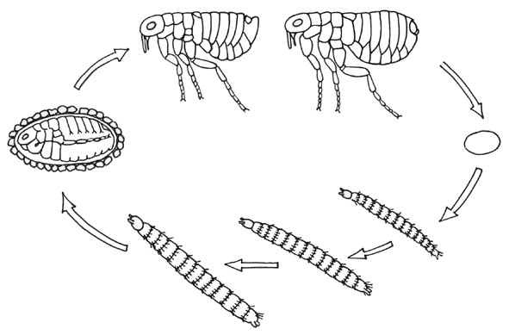

♀

♂

The larval abdomen bears one pair of anal struts. The larvae feed on organic debris found in the nest (or house) of the host. The larval diet often includes partially digested blood passed in the faeces of adult fleas. The larvae undergo two moults and mature after 2 to 3 weeks. They then produce silk and spin a cocoon within which they undergo a further moult and become a pupa. The pupal stage lasts for 1 to 2 weeks; the adult flea then sheds the pupal skin and remains dormant within the cocoon until triggered to emerge by specific stimuli. Adult fleas can copulate immediately after emergence and egg production can begin within 1 to 2 days of obtaining a blood meal.

Pathology of flea bites

When a flea feeds it injects saliva into the dermis to prevent the blood meal from coagulating. This causes an intense itching at the bite site which lasts for several days. Typically hypersensitivity develops in people exposed to repeated flea bites. A flea bite is characterised by a tiny dark spot surrounded by reddish and swollen skin.

Medically important fleas

The species which have the greatest impact on man are *Xenopsylla cheopis* (the plague flea), *Pulex irritans* (the human flea) and *Tunga penetrans* (the jigger flea). There are also a number of animal and bird fleas that will feed opportunistically on man and may cause a severe biting nuisance. Refer to Lane and Crosskey for keys to the medically important genera and species of fleas1.

Preparation of material

Adult fleas should be killed and stored in 80% ethanol prior to preparation. Transfer the flea to a watch glass or similar container containing 10% potassium hydroxide (KOH) solution for 24 hours, or longer, until the body contents are clear. Transfer the flea directly to a watch glass or similar container containing glacial acetic acid for a minimum of 2 hours. Then transfer the flea to clove oil for 2-24 hours until the body cavity is clear and the genitalia are visible. Mount the whole specimen in Euparal and add a coverslip. With care the specimen can be examined immediately. The specimen should be placed in an oven for 4-6 weeks at 55°C to give a permanent preparation. Label the slide with the identification, reference number and collection data.

*Xenopsylla cheopis* (plague or tropical rat flea)

Cosmopolitan in distribution, the flea is principally an ectoparasite of rats. It is a vector of plague and murine typhus.

Description

The flea is distinguished from other genera by the absence of both a genal and a pronotal comb, and the possession of a mesopleural rod within the second thoracic segment.

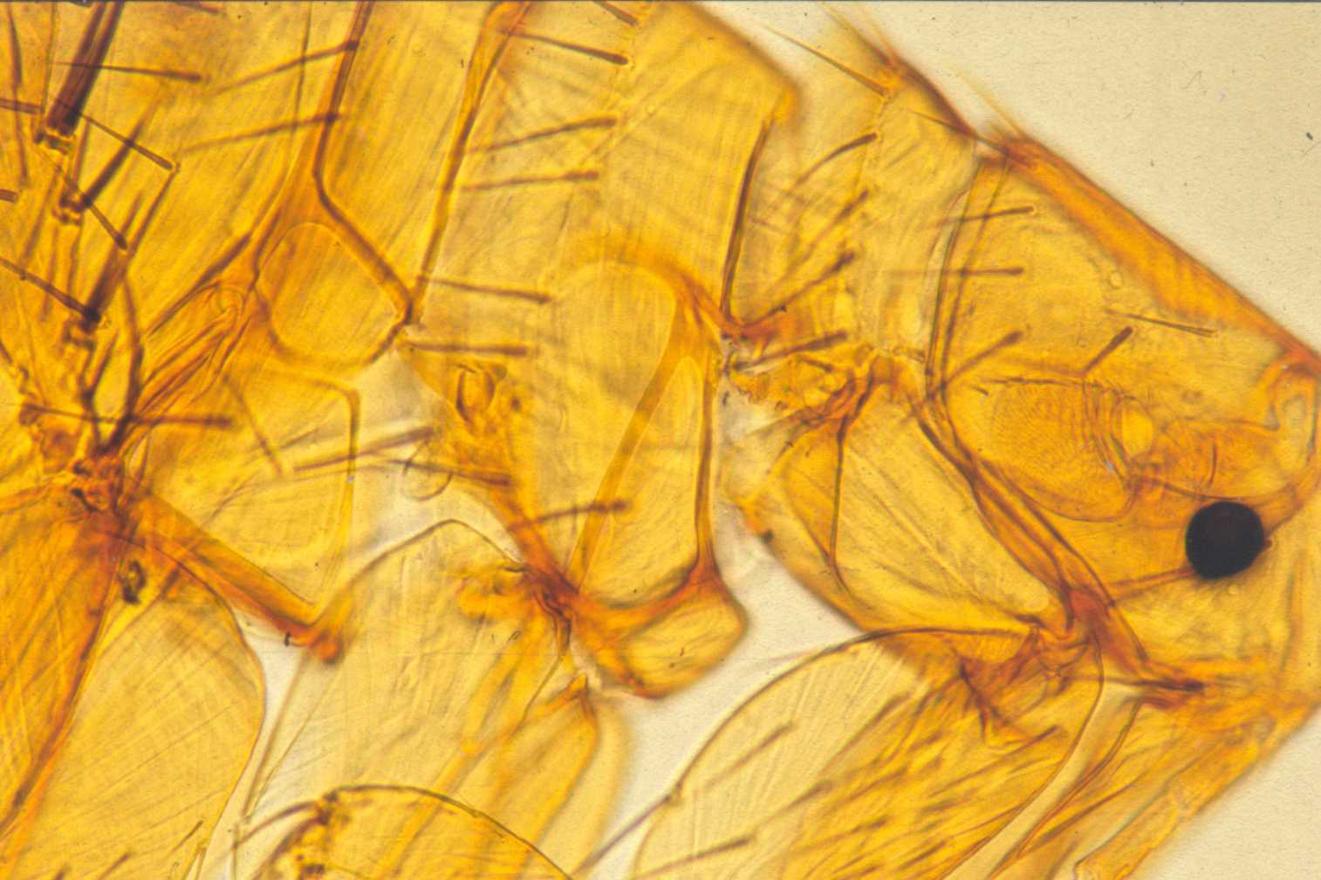

*Xenopsylla cheopis* (Illustration by C. Whitehorn)

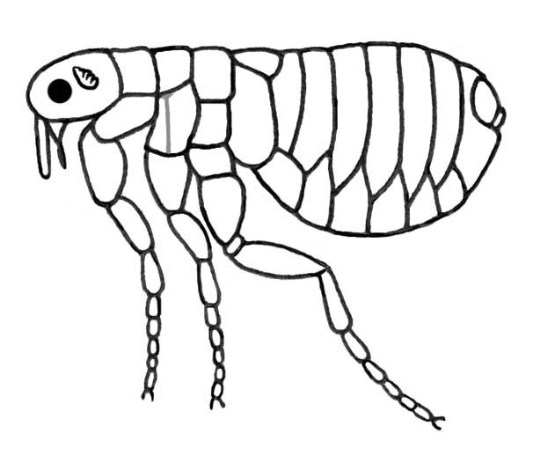

*Xenopsylla cheopis* Photograph of the head and thorax. © LSHTM

Mesopleural rod

Plague

Plague is a bacterial infection caused by *Yersinia pestis*. It is a zoonotic infection maintained in wild rodent populations (sylvatic plague) that is occasionally transmitted to commensal rats (urban plague). Commensal rats have less resistance to the disease and die in large numbers. The fleas that were living on them then seek alternative hosts. *Y. pestis* taken from an infected host in a blood meal undergoes a rapid multiplication in the stomach of the flea. The bacteria form a viscous plug that blocks the stomach and prevents the flea from feeding normally. When the flea attempts to feed, the blood comes up against the plug of bacteria and cannot enter the stomach. It is instead regurgitated by the flea back into the host and takes some of the bacteria with it, infecting the new host.

Murine typhus

Murine typhus is a rickettsial infection caused by *Rickettsia mooseri*. It is a zoonotic disease of rats and mice. The rickettsiae are ingested from an infected host with the blood meal. There is a multiplication of rickettsiae in the gut of the flea but no blockage occurs and the infective stages are passed out in the faeces. Transmission occurs when faeces from infected fleas are scratched into the skin, rubbed into mucous membranes or inhaled. Ingestion of contaminated fleas is also a route of infection.

*Pulex irritans* (human flea)

Cosmopolitan in distribution, the flea is principally an ectoparasite of coarse-coated mammals such as pigs, boar and deer, but also occurs on humans. It is mainly important as a biting nuisance, but is a vector of plague in the USA.

Description

The flea is distinguished from other genera by the absence of both a genal and a pronotal comb, and the presence of a thickened interantennal suture between the antennae. *P. irritans* does not have a mesopleural rod.

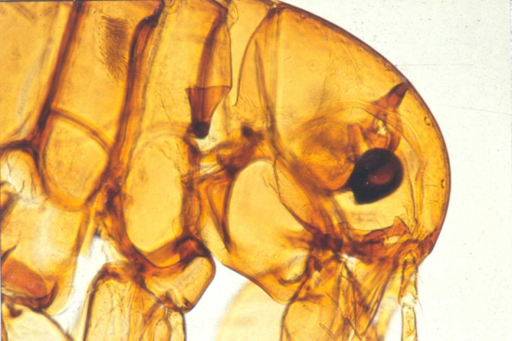

*Pulex irritans*

Photograph of head and thorax © LSHTM

*Pulex irritans* (Illustration by C. Whitehorn)

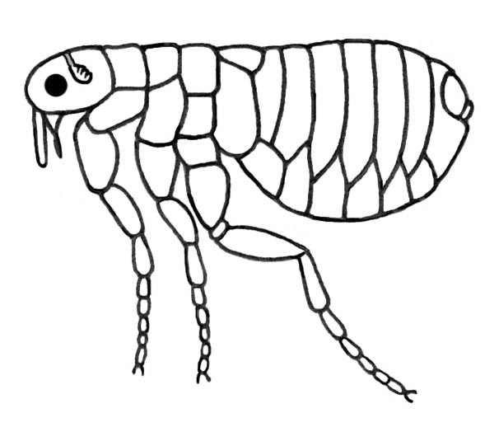

*Tunga penetrans* (the jigger flea)3

Distributed throughout tropical Africa, South and Central America, this flea is an ectoparasite of man, domestic livestock and rodents. Infestations of this flea cause the condition known as tungiasis; the female flea burrows into the skin of the host and becomes permanently attached.

Description

This type of flea is distinguished from other genera by its small size (1mm), the lack of a genal and pronotal comb, the compressed thoracic segments and the distinctive shape of the head.

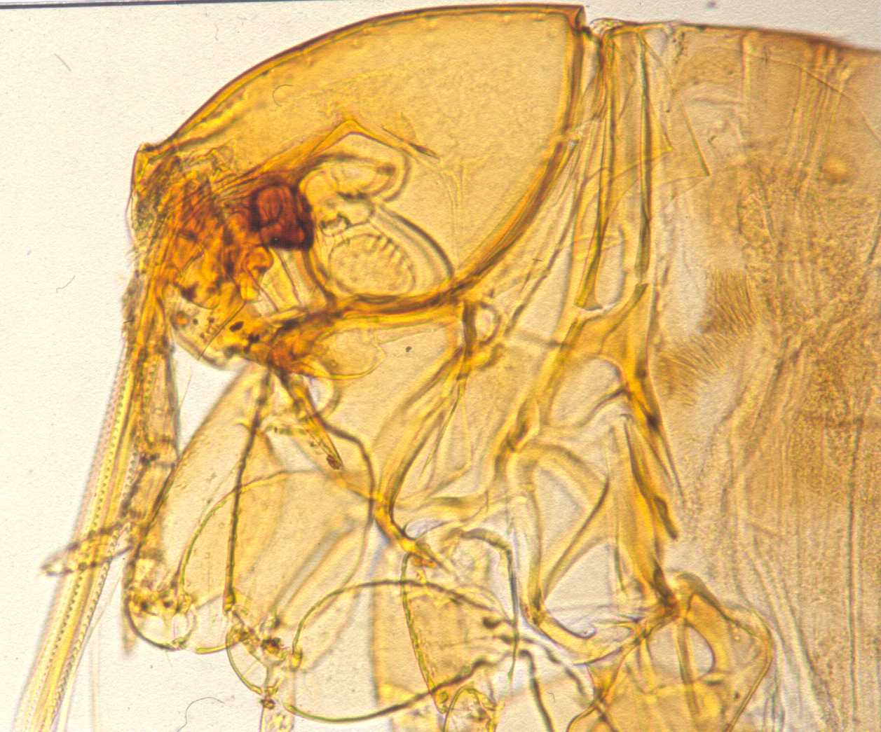

*Tunga penetrans*

Photograph of head and thorax.

© LSHTM

*Tunga penetrans*

(Illustration by C. Whitehorn)

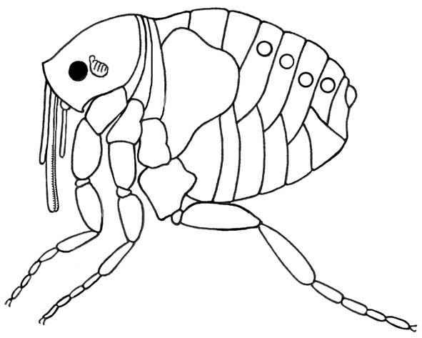

Tungiasis

Both male and female jigger fleas feed on blood, but the male flea will leave the host after taking a blood meal. The female flea once fertilised burrows into the skin of the host until she becomes totally embedded with only the tip of the abdomen exposed. Favoured sites include the foot, the toes and under the toenails, but any part of the body may be affected. As the female digests her blood meal, the eggs mature and she swells to the size and shape of a small pea. The enlargement results in considerable discomfort for the host. After 8-10 days the female has attained her maximum size and mature eggs are shed from the genital opening. Approximately 200 eggs are shed over a one to two week period. The eggs fall to the ground and hatch after 3-4 days. The larvae and pupae are found in sandy, well-drained soils. With larval development taking 10-14 days and the pupal stage 5-14 days, the entire lifecycle is completed in 35 days on average. When the female flea dies she remains embedded in the skin, causing inflammation that may lead to secondary infections. Loss of toes, tetanus and gangrene may occur.

Animal and bird fleas2

A number of animal and bird fleas will bite man opportunistically and can cause considerable biting nuisance. These fleas can also act as intermediate hosts of animal tapeworms. The most important genera are *Ctenocephalides* (cat and dog fleas) and *Ceratophyllus* (bird fleas), and to a lesser extent *Nosopsyllus* (rat fleas) and *Leptopsylla* (mouse fleas)1.

Description

The animal and bird fleas all possess a pronotal comb. The number of spines present in the pronotal comb is important for identification. *Leptopsylla* species and *Ctenocephalides* species also possess a genal comb.

*Ctenocephalides felis* (the cat flea)

Cosmopolitan in distribution, *C. felis* is an ectoparasite of cats and dogs, and is the flea that most commonly bites man in the UK. It can be distinguished from the dog flea *C. canis* by the elongate head of the adult and the arrangement of setae on the hind tibia1. *C. felis* can act as the intermediate host of the dog tapeworm *Dipylidium caninum* and the mouse tapeworm *Hymenolepis diminuta.*

Description

The cat flea is distinguished from other genera by the presence of a genal comb (of 7 to 8 points), a pronotal comb and the presence of a mesopleural rod. The head of the cat flea is twice as long as high and is pointed anteriorly. The hind tibia has six seta-bearing notches along the dorsal margin1.

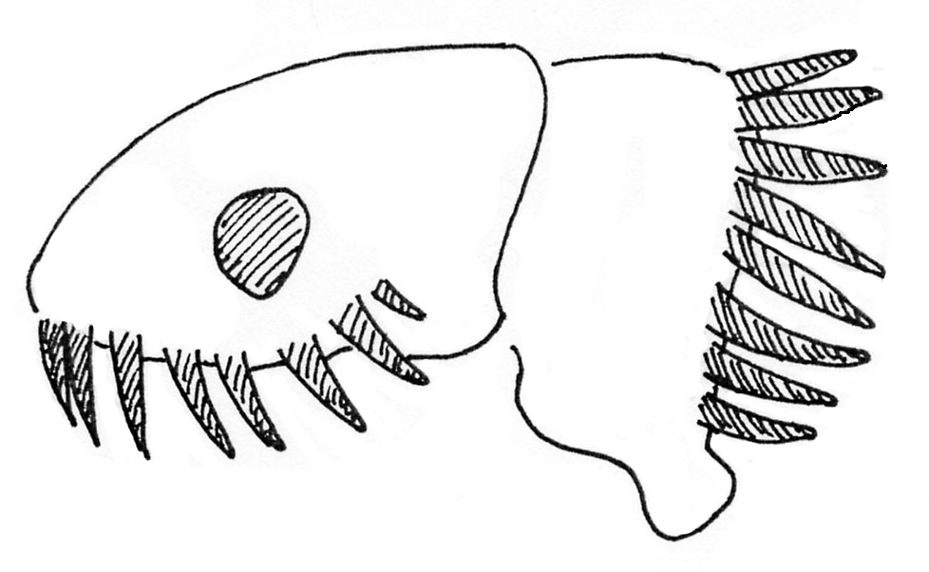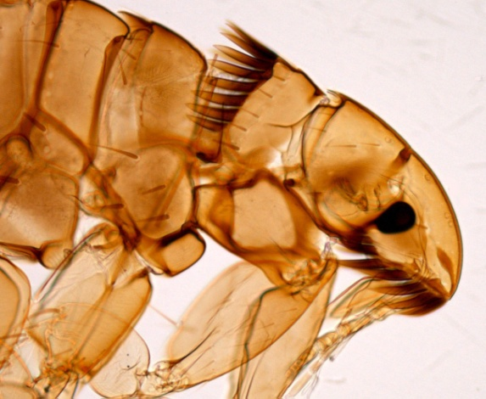

*Ctenocephalides felis*

Drawing of head and first thoracic segments.

(Illustration by C. Whitehorn)

*Ctenocephalides felis*

Photograph of head, first and second thoracic segments. **Note:** combs visible.

© LSHTM

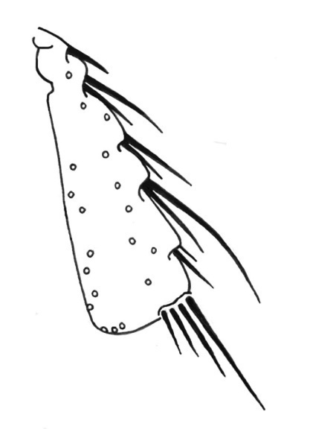

*Ctenocephalides felis*

Drawing of hind tibia.

(Illustration by C. Whitehorn)

**Note:** Circles denote the origin of additional setae that are not illustrated.

*Ctenocephalides canis* (the dog flea)

Cosmopolitan in distribution, *C. canis* is found on both cats and dogs, and will also bite man. *C. canis* is less common in the UK than the cat flea. The dog flea is distinguished from the cat flea by its rounded head and the arrangement of setae on the hind tibia. *C. canis* can act as the intermediate host of the dog tapeworm *Dipylidium caninum*.

Description

The dog flea is distinguished from other genera by the presence of a genal comb (of 7 to 8 points), a pronotal comb and the presence of a mesopleural rod. The head of   
*C. canis* is rounded anteriorly and its length is up to twice that of its height. The hind tibia has eight seta-bearing notches along the dorsal margin1.

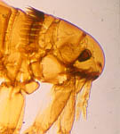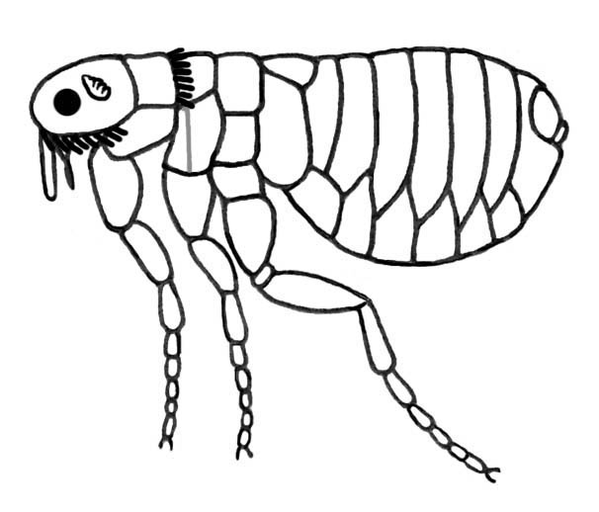

*Ctenocephalides canis*

Photograph of head, the first and second thoracic segments.

© LSHTM

© LSHTM

*Ctenocephalides canis*

(Illustration by C. Whitehorn)

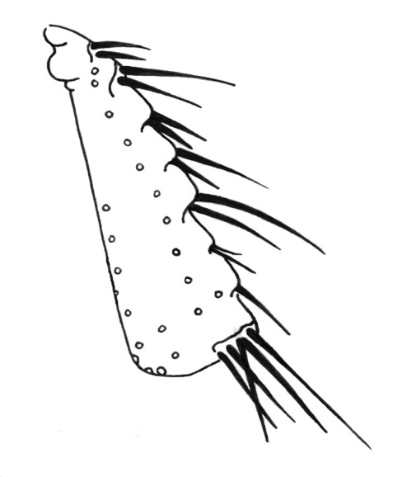

*Ctenocephalides canis*

Drawing of hind tibia.

(Illustration by C. Whitehorn)

**Note:** Circles denote the origin of additional setae that are not illustrated

*Ceratophyllus* (the bird flea) and *Nosopsyllus* (the rat flea)

Both these genera are found in the family Ceratophyllidae and share a number of morphological characters. They can be distinguished only by examination of the genitalia. The common chicken flea (*Ceratophyllu*s *gallinae*) is cosmopolitan in distribution and is an ectoparasite of domestic poultry and wild birds (such as pigeons, starlings and sparrows). This species will bite man opportunistically and causes considerable biting nuisance. The rat flea (*Nosopsyllus* species) is also cosmopolitan in distribution and is the ectoparasite of a number of rodent species.

Description

These fleas are distinguished from the other medically important genera by the presence of a pronotal comb, a mesopleural rod and a well-developed pleural arch (located between the third thoracic segment and the abdomen).

*Nosopsyllus* species

Drawing of head and thorax.

**Note:** pleural arch in third thoracic segment.

(Illustration by C. Whitehorn)

*Nosopsyllus* species

Photograph of head, first and

second thoracic segments.

© LSHTM.

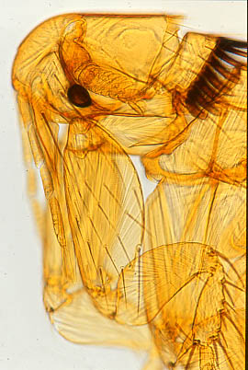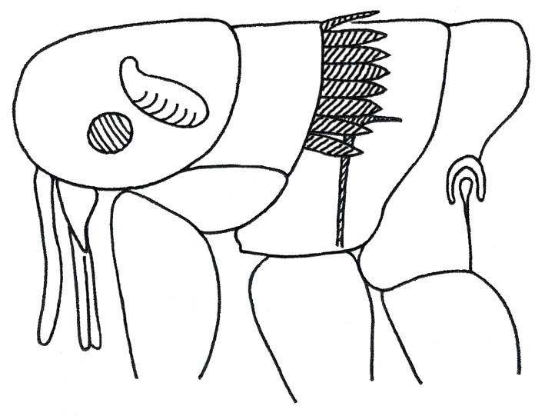

*Leptopsylla* (the mouse flea)

Distributed throughout the Palaearctic, Nearctic and Afrotropical regions members of the genus *Leptopsylla* are primarily ectoparasites of small rodents.

Description

These fleas are distinguished from other genera by the distinctive shape of the head (that appears folded), the presence of a pronotal comb and a reduced genal comb, and the absence of eyes.

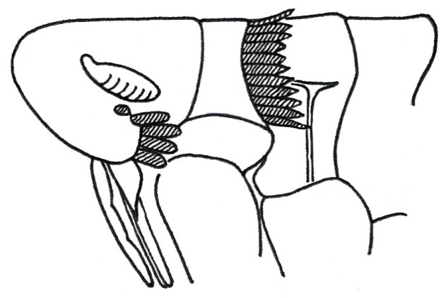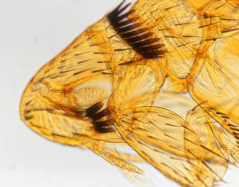

*Leptopsylla* species

Drawing of head, first, second and part of the third thoracic segment.

(Illustration by C. Whitehorn)

*Leptopsylla* species

Photograph of head, first and second thoracic segments.

© LSHTM

Table 1: Fleas associated with man

|  |  |  |  |  |  |  |
| --- | --- | --- | --- | --- | --- | --- |
| **Genus** | **Host** | **Head** | **Genal-comb** | **Pronotal-**  **comb** | **Eyes** | **Mesopleural rod** |
| **Pulex** | Human and other mammals | Normal | Absent | Absent | Present | Absent |
| **Xenopsylla** | Rats | Normal | Absent | Absent | Present | Present |
| **Tunga** | Human and domestic animals | Upturned | Absent | Absent | Present | Absent |
| **Ctenocephalides** | Cat/Dog | Normal | Present | Present | Present | Present |
| **Ceratophyllus** | Birds | Normal | Absent | Present | Present | Present |
| **Nosopsyllus** | Rats | Normal | Absent | Present | Present | Present |
| **Leptopsylla** | Mice | Folded | Present | Present | Absent | Present |

Ceratophyllusand Nosopsyllusalso have a pleural arch located between the third thoracic segment and the abdomen.

Lice2,4

Human lice

Lice (order: Anoplura) are true insects (class: Insecta) and as such have a segmented body that is clearly divided into head, thorax and abdomen. In the nymph and adult stages the thorax bears six legs.

Lice are obligate parasites of vertebrate hosts throughout their lifecycle. They are host specific and may even exhibit region specific behaviour on that host. There are three species of lice found on man and of these only one, *Pediculus* *humanus*, is a vector of disease.

Description

Human lice are small (2-4mm long), wingless insects that vary in colour from cream to dark brown depending on their host. The body is flattened dorso-ventrally and is covered with a leathery integument. The body is clearly divided into head, thorax and abdomen but the thorax and abdomen are fused. The head bears a pair of small eyes and one pair of short antennae. The thorax bears three pairs of legs with strong claws for clinging to the host. The human lice are classified in two genera; *Pediculus* species (the clothing and head lice) and *Phthirus* species (the crab louse).

Lifecycle5,6

Lice exhibit an incomplete metamorphosis with the immature stages resembling the adult and occupying the same ecological niche. They spend their entire lifecycle on the host and depart only to transfer to a new host. Adult head lice live on average 22 days and the females lay about 50 eggs over their lifetime. Adult clothing lice live on average 30 days and the females lay about 100 eggs over their lifetime. Adult crab lice live for approximately 22 days and the females lay about 50 eggs over their lifetime. Eggs hatch after 6-8 days in all cases (at 35°C) and a small nymph emerges. There are 3 nymph stages. For the head and clothing lice, nymph development takes approximately 9 days to complete. For the crab louse, nymph development takes 15-17 days. Human lice need to take regular feeds throughout the day and are very sensitive to changes in temperature and humidity.

*Pediculus capitis*

Diagram of head louse lifecycle.

(Illustrated by C. Whitehorn)

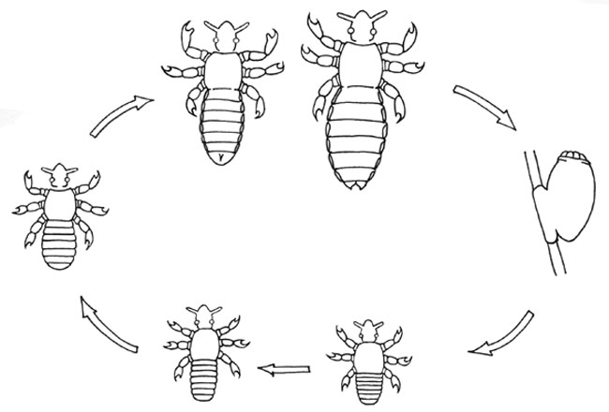

Pathology of lice bites5,6

Lice are equipped with discrete mouthparts contained in a ventral pouch. When a louse feeds it attaches to the skin using a toothed haustellum and pierces the skin with needle-like stylets. Saliva is injected into the wound to prevent coagulation and the blood is sucked up through a flexible tube-like mouth. The bites of human lice result in small red spots 2-3mm across. Sensitivity to lice bites may develop over a period of weeks or months (depending on the level of exposure) and once established the skin irritation may be severe. The need for lice to take regular feeds means that the host will be exposed to repeated doses of saliva and a toxic reaction may occur in some individuals with symptoms of weariness, irritability and depression (the person feels ‘lousy’).

Medically important lice

Only the clothing louse *Pediculus* *humanus* is a vector of disease, transmitting louse-borne epidemic typhus, quintana fever and louse-borne relapsing fever. However the regular feeding habits of lice mean that severe biting nuisance is associated with all three species.

Preparation of material

Lice should be killed in hot water (85°C) and stored in 80% ethanol prior to preparation. Transfer the louse into a watch glass on similar container containing 10% potassium hydroxide (KOH) solution. Pierce the dorsal inter-segmental membranes with a fine needle and leave the louse in the solution for 24 hours. The KOH penetrates and dissolves the body tissues. Apply gentle pressure to the body of the louse with a blunt needle to remove the liquefied body contents. Rinse the louse in distilled water three times (10 minutes per rinse). Dehydrate in increasing strengths of ethanol 80% (5 mins), 90% (5 mins), 100% (5 mins) and finally place in a watch glass on similar container containing cellosolve for 15 minutes. Mount the whole specimen in Euparal and carefully add a coverslip. With care the specimen may be examined immediately. The specimen should be placed in an oven for 4-6 weeks at 55°C to give a permanent slide preparation. Label the slide with the identification, reference number and collection details of the specimen.

*Pediculus Humanus* (the clothing louse)

Cosmopolitan in distribution, the clothing louse is associated with displaced populations where people are unable to wash or change clothes frequently. The most robust of the human lice it can survive several days away from the host in infested clothing.

Description

Adult

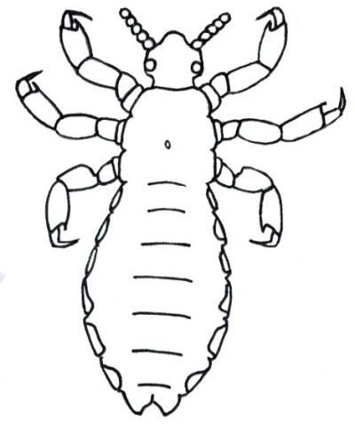The human *Pediculus* species are elongate insects which grow to a length of about 4mm. The body regions are clearly differentiated and the legs bear claws of a moderate size. Females are slightly larger than males. Clothing lice and head lice are practically identical and are differentiated by their location on the host. Clothing lice are found in the fabric covering the body particularly in the seams around the crotch, armpits, waist, collar and shoulders. They attach to body hair only when feeding and are never found on the head.

*Pediculus humanus*. Diagram of a female clothing louse.

**Note:** Tip of abdomen bifurcated.

(Illustration by C. Whitehorn)

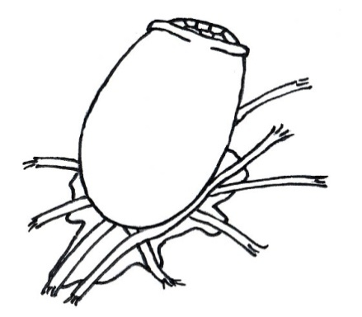

*Pediculus humanus*.

Diagram of egg glued to material fibres.

(Illustration by C. Whitehorn)

Egg

The eggs of *Pediculus* species are small (0.8mm long), cream in colour and oval in shape7. At the distal end is a shallow perforated operculum that provides gaseous exchange to the embryo. The eggs of clothing and head lice are so similar that their location on the host is the primary method of differentiating the two species. Clothing lice eggs are found in the clothing glued to material fibres, especially in the seams of undergarments. They are occasionally glued to body hairs, but clothing lice eggs are never found on the head.

Louse-borne epidemic typhus

Louse-borne typhus is a rickettsial disease caused by *Rickettsia prowazekii.* The rickettsiae are ingested from the host during a blood meal and undergo multiplication in the lumen and epithelial cells of the louse midgut. The epithelial cells eventually rupture, releasing infective stages which are passed out in the faeces. The rickettsiae remain infective to humans in the louse faeces for up to 3 months and transmission occurs when faeces are scratched into the skin, rubbed into mucous membranes or inhaled. People without lice can therefore become infected with typhus. *R. prowazekii* has also been isolated from the American flying squirrel, but the significance of this for transmission is uncertain.

Quintana fever

Quintana fever is a bacterial disease caused by *Bartonella quintana*. The bacteria are ingested from the host during a blood meal and undergo multiplication in the lumen of the gut but the epithelial cells are not invaded. After 5-10 days the infective forms contaminate the faeces and they pass from the vector. The transmission route and symptoms are similar to louse-borne typhus but the disease is much less severe. Wild voles and other rodents may act as reservoirs of disease.

Louse-borne relapsing fever

The disease is caused by the spirochaete, *Borrelia recurrentis*. Humans are the sole reservoir of disease. The spirochaetes are ingested by the louse during feeding and penetrate the gut to multiply in the haemolymph. Transmission occurs when lice are ingested by humans or are crushed into abraded skin or crushed between the teeth. The disease is seldom seen in humans who are free of lice.

*Pediculus capitis* (the head louse)

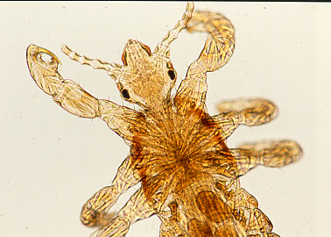Cosmopolitan in distribution, infestation is primarily seen in nursery and primary school children. Transmission of lice occurs during head to head contact. Lice do not survive if removed from the host.

Description

Adult

There are very few morphological differences between head and body lice but they can be distinguished by their location on the host. Head lice are only found on the hairs of the scalp.

*Pediculus capitis* - male

Photograph of the head and thorax

© LSHTM

Egg

The eggs of *Pediculus* species are small (0.8mm long), cream in colour and oval in shape7. At the distal end is a shallow perforated operculum that provides gaseous exchange to the embryo. The eggs of the head louse are differentiated from those of the body louse by their location, with head louse eggs restricted to the hairs of the scalp and no other part of the body.

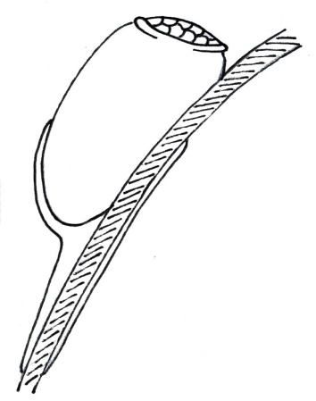

*Pediculus capitis* – egg

Diagram of egg glued

to strand of hair

(Illustrated by C. Whitehorn)

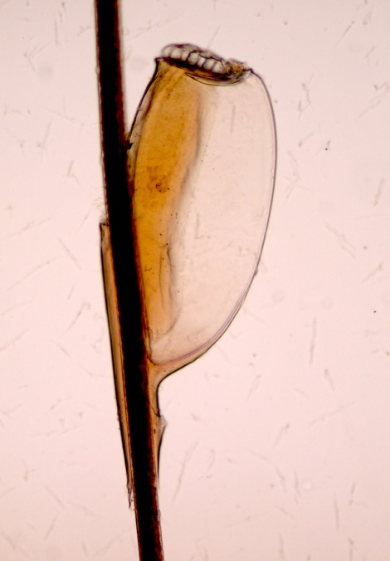

*Pediculus capitis*

Photograph of head louse egg attached to strand of hair.

© LSHTM

*Phthirus pubis* (the crab louse)

Cosmopolitan in distribution, infestation is primarily seen in sexually active adults. Infestation occurs on the coarse hairs of the body such as the pubic hair and eyelashes. In men the chest hair, beard and moustache may also be infested. Transmission of crab lice occurs during close physical contact.

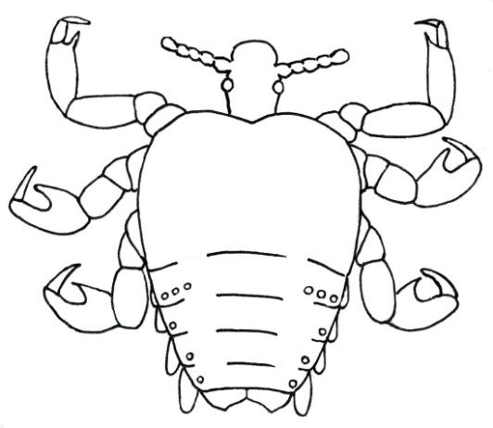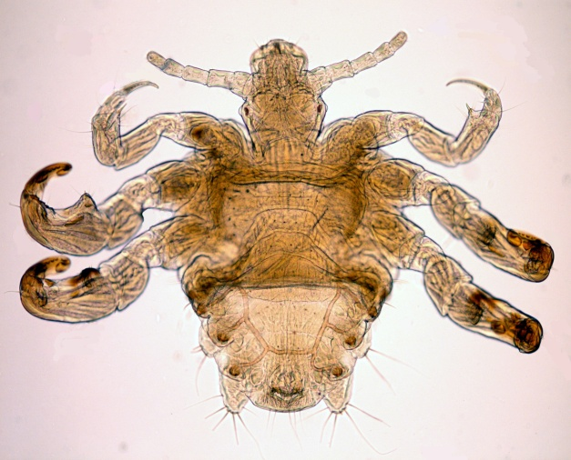

*Phthirus pubis*

Diagram of crab louse – female

(Illustration by C. Whitehorn).

*Phthirus pubis*

Photograph of crab louse – male

© LSHTM

Description

Adult

*Phthirus pubis* is a compact rounded insect (1.0–1.4mm in diameter) with enlarged claws on the second and third pairs of legs. The abdomen is reduced both in size and number of segments, and there is no clear differentiation between the thorax and the abdomen. *Phthirus* resembles a tiny crab and hence its common name – the crab louse.

Egg

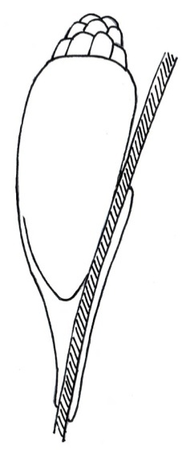The eggs of *Phthirus pubis* are small (0.8mm long), cream in colour and oval in shape7. At the distal end is a raised perforated operculum that provides gaseous exchange to the embryo. The shape of the operculum differentiates the eggs of the crab louse from those of head and body lice.

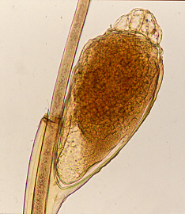

*Phthirus pubis* – egg Photograph of egg glued to strand of hair.

**Note:** raised

operculum.

© LSHTM

*Phthirus pubis* – egg

Diagram of egg glued

to strand of hair.

(Illustration by C. Whitehorn)

Although crab lice eggs may be found on the head of the host they are restricted to areas of coarse hair growth such as eyebrows, eyelashes, beards and moustaches. Crab lice eggs are not found on the hairs of the scalp.

Bedbugs2

Bedbugs (order: Hemiptera) are true insects (class: Insecta) and as such have a segmented body that is clearly divided into head, thorax and abdomen. In the nymph and adult stages the thorax bears six legs.

Bedbugs are obligate bloodsucking parasites of vertebrate animals. They are principally nocturnal and hide away in cracks and crevices during the day. Only two species are associated with man: *Cimex lectularius* (the common bedbug) and *Cimex hemipterus* (the tropical bedbug). Although these two species predominantly feed on man they may bite other mammals or birds. The medical importance of bedbugs is open to dispute, but they are responsible for considerable biting nuisance.

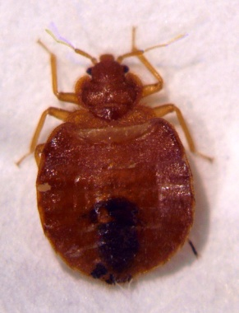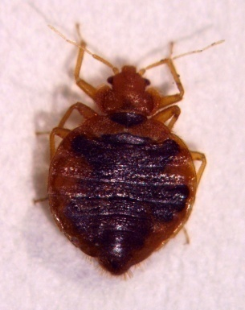

Photograph of *Cimex lectularius*

Female dorsal view.

© LSHTM

Photograph of *Cimex lectularius*

Male dorsal view.

© LSHTM

Description

Adult bedbugs are small (5mm long by 3mm wide), oval insects that vary in colour from yellowish to dark brown and appear dark red if recently fed. The body is flattened dorso-ventrally and clearly divided into head, thorax and abdomen. The head is short and broad with one pair of eyes and one pair of 4-segmented antennae. Folded beneath the head is the proboscis (a 3-segmented rostrum) which is swung forward when the bug feeds. The thorax is divided into three segments and the shape of the first segment (pronotum) is used to distinguish the common bedbug from the tropical bedbug. Dorsally the second and third thoracic segments are partially obscured by the two pad-like wings which are non-functional. The legs are well developed and bedbugs can move very quickly if disturbed.

The male can be distinguished from the female by examination of the abdomen. The male abdomen is narrower, slightly pointed and asymmetrical in outline. The female abdomen is rounded and symmetrical in outline.

*Cimex lectularius*

Drawing of female bedbug ventral view.

(Illustration by C. Whitehorn)

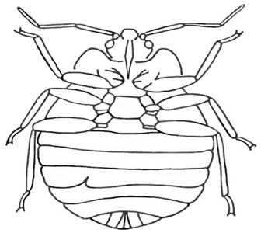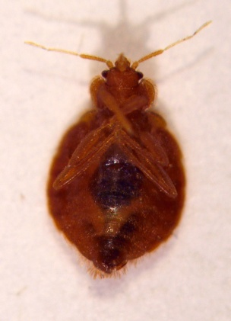

Photograph of *Cimex lectularius*

Male ventral view.

© LSHTM

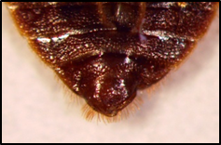In ventral view the terminal segment of the male bears a curved hook-like paramere (or penis), the external genitalia. In the female, the fourth abdominal segment bears a distinct slit to the left of the midline which opens into the copulatory pouch.

*Cimex lectularius*

Drawing of male bedbug ventral view.

(Illustration by C. Whitehorn)

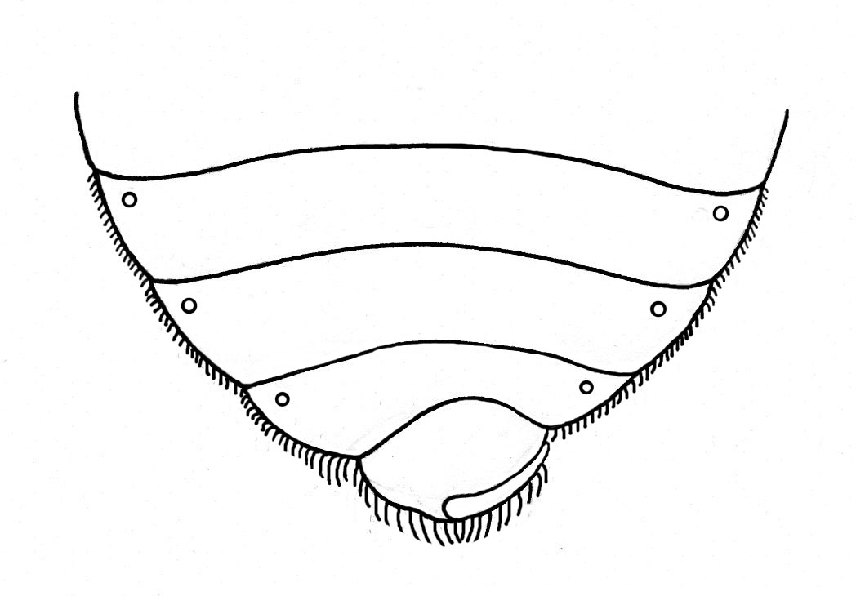

Photograph of *Cimex lectularius*

Close-up of male ventral view.

© LSHTM

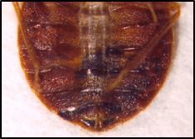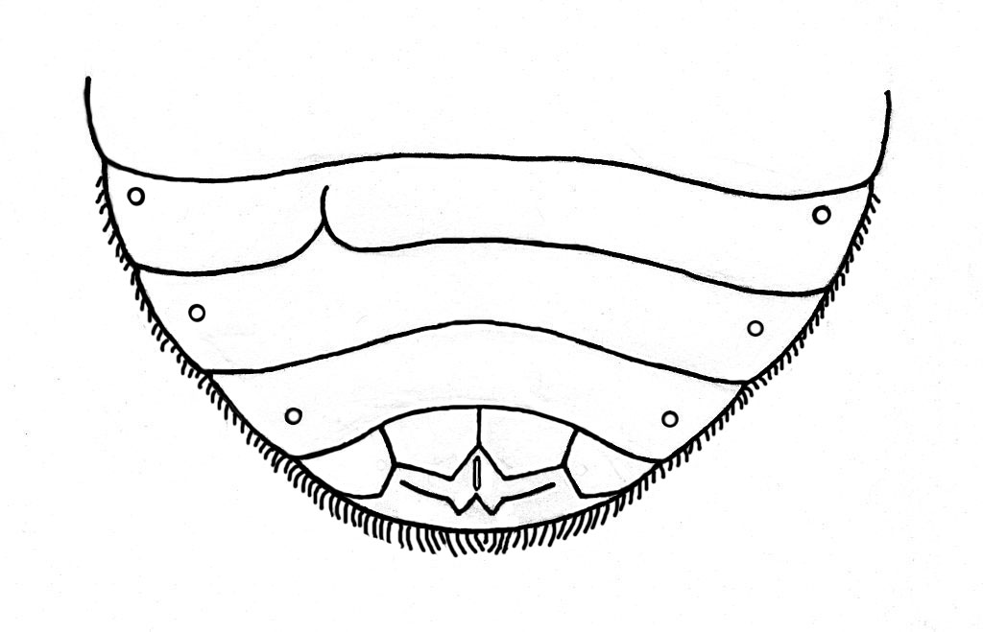

*Cimex lectularius*

Drawing of female bedbug ventral view.

(Illustration by C. Whitehorn)

Photograph of *Cimex lectularius*

Close-up of female ventral view.

© LSHTM

Lifecycle

Bedbugs undergo an incomplete metamorphosis, and the immature and adult stages occupy identical ecological niches. Female bedbugs glue eggs in the cracks and crevices of walls and furniture. Each female may lay 300 eggs over her lifetime depending on environmental conditions and access to blood meals. The eggs are elongate, cream to pink, operculate and approximately 1mm long. Eggs hatch after about 10 days and the first instar nymph emerges. There are 5 nymphal instars and each requires a blood meal to facilitate a moult to the next stage. Nymphs can survive for 4 months without a blood meal and adults can survive for over a year without feeding. The average time for completion of the lifecycle is 10 weeks but development is strongly influenced by temperature, humidity, host availability and habitat.

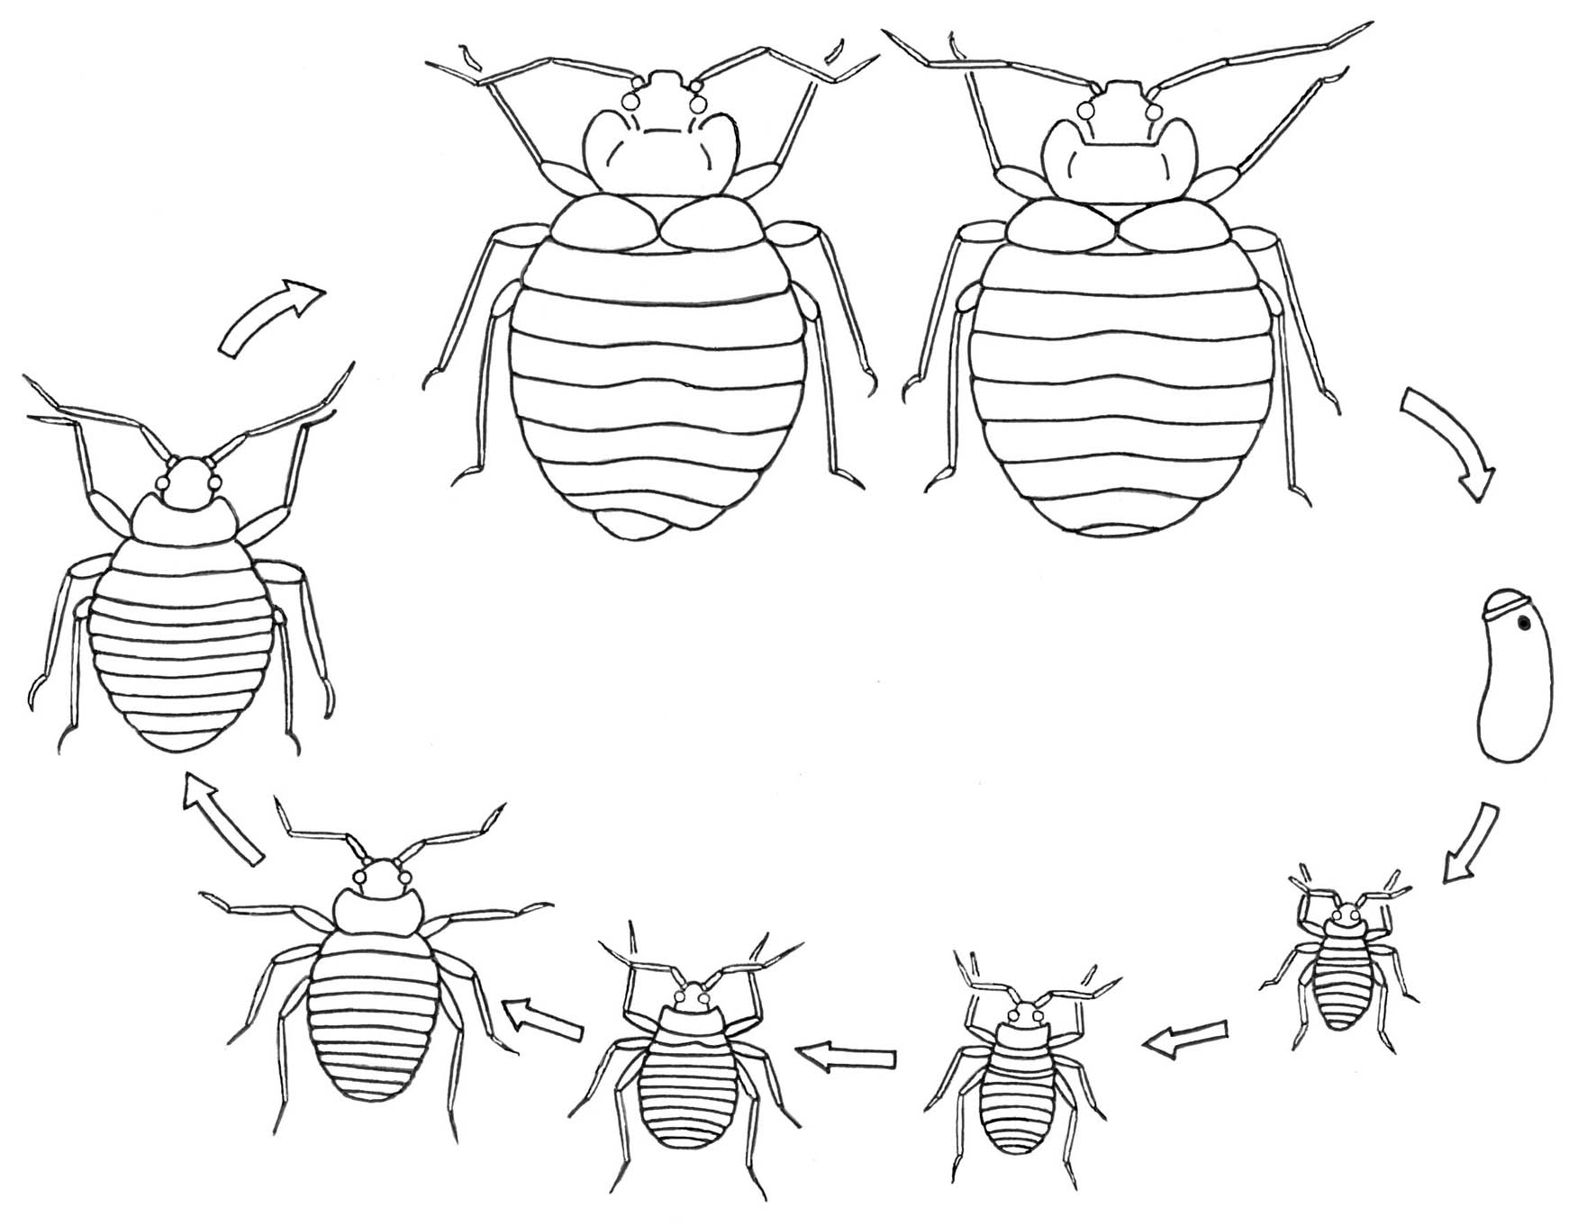

Diagram of the common bedbug lifecycle.

(Illustration by C. Whitehorn)

Signs and symptoms8

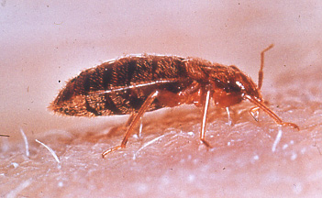Bedbugs are believed to be transferred between houses within infested furniture and bedding. They are found across a broad range of premises from luxury properties to poor quality housing and predominantly in short-term accommodation such as hotels and hostels. Local dispersal of infestations can occur when bedbugs travel along the ducts, risers and central heating pipes that connect adjacent rooms. On average it can take 7 weeks for the infestation in one room to be detected in adjoining rooms. Such dispersal can occur even in the absence of any significant competition pressure. Adult bedbugs have scent glands that produce an odour when the bugs are disturbed. Properties with a heavy infestation may be identified by the musty, sweet, sweaty scent of this odour. Faecal spots around resting sites and the presence of cast skins would also indicate an infestation.

**Reaction to bedbug bites** varies considerably between individuals. Some people have no sensitivity to the saliva of bedbugs and are completely unaware that they are being bitten. However, in the majority of cases a localised itchy swelling will occur at the site of a bite approximately 15 to 30 minutes after feeding and may persist for several days. The interval between feeding and the occurrence of a reaction will depend on the host’s immunological status. During the actual process of feeding the host normally feels no sensation at the bite site. Traditionally bites would occur on the head and shoulders of the person, as these were the exposed areas above close fitting bed sheets and blankets. A more diffuse feeding pattern may be seen with the use of loose fitting duvet covers or if the bugs are in other types of furnishings.

Photograph of *Cimex* species feeding. © LSHTM

Medical importance

In the laboratory, bedbugs have been infected with hepatitis B, HIV and *Trypanosoma cruzi*, but there is little evidence to suggest that bed-bugs are significant vectors of human pathogens.

Preparation of material

Bedbugs should be killed by immersion in hot water (85°C) and then preserved in 70% ethanol. Bedbugs do not need to be slide mounted for identification, but simply placed into a watch glass or similar container containing 70% ethanol and examined under a dissecting microscope.

*Cimex lectularius* (the common bedbug)

In the UK the common bedbug is the predominant species responsible for domestic infestations. Over the last five years there has been a significant increase in cases but the reasons for this are unclear. Bedbugs continue to be associated with poverty and poor hygiene which makes frank discussion of this pest problematic.

Description

Common bedbugs are approximately 4.5mm in length and 3mm in width. They are slightly smaller than the tropical bedbug and have a more rounded abdomen. Examination of the dorsal body surface shows that the pronotum (the first thoracic segment) is extended laterally into upturned flanges.

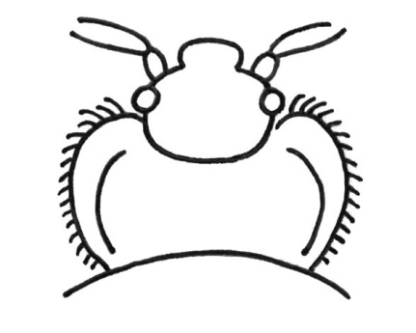

*Cimex lectularius*

Drawing of head and

pronotum x 30.

(Illustration by C. Whitehorn)

*Cimex hemipterus* (the tropical bedbug)

This species is common throughout the tropics and with the increase in international travel there was always the possibility that it might be introduced into the UK. There have been a small number of cases of domestic infestation by tropical bedbugs reported in recent years.

Description

Tropical bedbugs are approximately 5mm in length and 2.5mm in width. They are slightly larger than the common bedbug and have a slightly more elongated abdomen. Examination of the dorsal body surface shows that the pronotum (the first thoracic segment) is rounded and lacks lateral flanges.

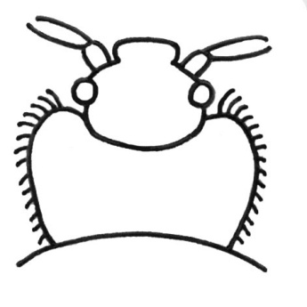

*Cimex hemipterus*

Drawing of head and

pronotum x 30.

(Illustration by C. Whitehorn)

.

Mites2

Mites (subclass: Acari) are arachnids (class: Arachnida) and as such have a fused body that shows no division into head, thorax and abdomen. The body bears eight legs in the adult stages.

Mites are microscopic arachnids that occupy a diverse array of ecological niches. They are found in soil, air and water. They feed on plants, organic matter, other micro-organisms and occasionally vertebrates. The number of mites that are associated with man and that are of medical importance is extremely low. Mites typically require slide mounting and examination under a compound microscope for identification.

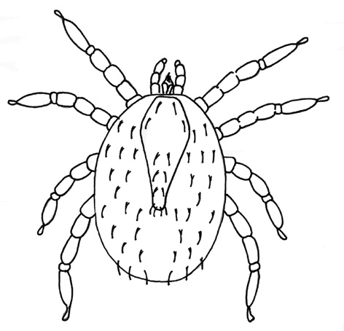

A generalised mite.

(Illustration by C. Whitehorn)

Description

Mites are very small and normally range in size from 0.09–1.0mm in length (a few species can reach 15mm in length). The body is covered in a flexible cuticle that bears numerous setae often arranged in distinctive patterns. There is no division of the body into head, thorax and abdomen but the conspicuous mouthparts may be confused with a head. Mouthparts consist of a pair of palps and a pair of chelicerae (cutting/piercing apparatus). Adult and nymphal stages have eight legs whereas the larval stage has six legs. Larvae could thus be confused with insects but for their lack of body division. Mites may be differentiated from ticks by the following characters: mites have no prominent toothed hypostome in the mouthparts and no Haller’s organ on the tarsi of the foreleg (see tick section).

Although mites are generally much smaller than ticks, size is not the best character for differentiating the two groups. Mites often have sclerotized regions on the body surface called shields and these, together with the setae that arise from them, are useful characters for identification.

Lifecycle

Mites demonstrate an incomplete lifecycle but the immature and adult stages may occupy widely different ecological niches. Lifecyclesare given for each of the medically important mites in the appropriate section but a generalised lifecycle follows: egg to six-legged larva, larva to eight-legged nymphal stage/s, nymph to adult. Female mites produce a small number of relatively large eggs which hatch to give the larva. After feeding the larva moults to give the nymph and the nymph may have up to three developmental stages (depending on species); protonymph, deutonymph and tritonymph. At least one nymphal stage is dormant. The nymph eventually moults to give the adult.

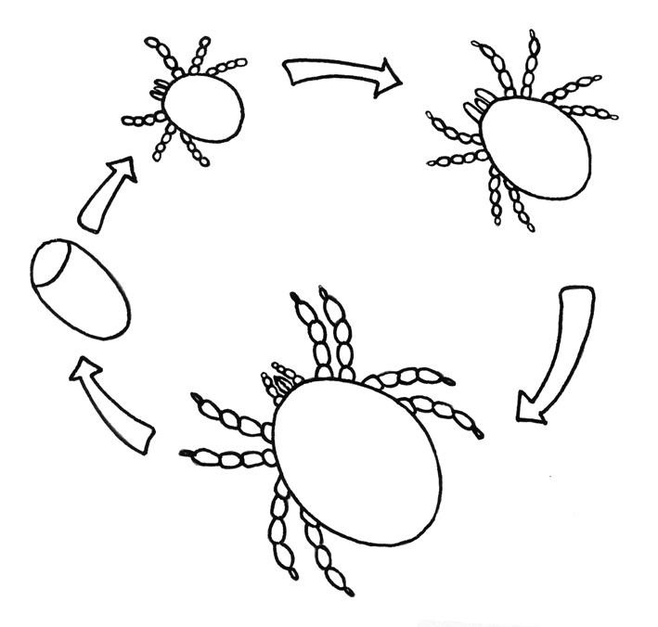

A simplified mite lifecycle.

(Illustrated by C. Whitehorn)

Medically important mites

The ectoparasitic mites of medical importance are *Sarcoptes scabiei* (scabies mite, itch mite), *Demodex* species (follicle mites) and trombiculid mites (chiggers). Some animal and bird mites may bite man in the absence of their primary hosts and *Dermanyssus gallinae* (the chicken mite) is given as an example. Refer to Lane and Crosskey and Baker for keys to the families and genera of parasitic mites9.

Preparation of material

Mites should be killed and preserved in 70% ethanol or Oudeman’s solution prior to preparation (Oudeman’s solution prevents dehydration of specimens in long term storage. It consists of 87 parts 70% ethanol, 5 parts glycerine and 8 parts glacial acetic acid). Transfer soft-bodied or weakly sclerotized mites into a drop of Hoyer’s medium on a slide, add a coverslip and examine with care (Hoyer’s medium consists of 50mL distilled water, 30g crystalline gum Arabic, 200g chloral hydrate and 20mL glycerine). Sclerotized mites should be cleared prior to slide mounting by transferring to lactophenol for 4 to 72 hours till clear (Lactophenol consists of 50 parts lactic acid, 25 parts phenol crystals and 25 parts distilled water). When clear the mite should be rinsed three times in distilled water (10 minutes each rinse) and mounted in Hoyer’s medium as above. For a permanent preparation the slide should be baked at 50°C in an incubator for 4 days and the coverslip ringed with clear nail varnish. Label the slide with the identification, reference number and collection data9.

*Sarcoptes scabiei* (the scabies mite)3

Cosmopolitan in distribution, *Sarcoptes scabiei* causes scabies in man and can affect people of any socio-economic class. A number of other species of *Sarcoptes* cause mange in pets and domestic animals but these mites are not viable on man. Scabies mites burrow through the upper layers of the skin feeding on the dermal tissues. Clinical symptoms result from sensitisation to the mites and to their faeces. Extensive and permanent burrows are only produced by the female mite and she is capable of living for up to two months on the human host. Scabies is transmitted from person to person only by close and prolonged physical contact.

Description

Scabies mites are very small; the males 0.2mm and the females 0.3 - 0.4mm. They have a striated cuticle bearing specialised scales and bristles. The legs are short and the forelegs bear specialised setae (pulvilli) to grip to the skin of the host.

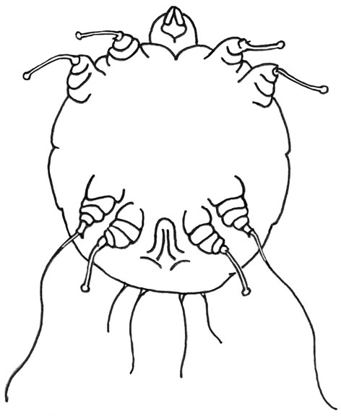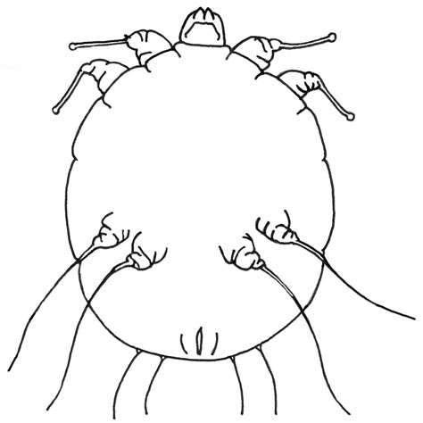

*Sarcoptes scabiei*

Diagram of male mite

(Illustration by C. Whitehorn)

*Sarcoptes scabiei*

Diagram of female mite

(Illustration by C. Whitehorn)

Males can be differentiated from females by the presence of pulvilli on the hind pair of legs. These are used to hold on to the female during mating.

Lifecycle

The female mite lays eggs in her burrow as she tunnels through the skin. Eggs are oval and 0.1 - 0.15mm in length. They hatch in 3-8 days and a hexapod larva emerges. The larvae exit the burrow and migrate to the surface of the skin where they enter a hair follicle or burrow into the stratum corneum to construct a “moulting pouch”. The larva moults to an octapod nymph after 2-3 days. There are two nymphal stages prior to the adult stage. Mating occurs when the adult male penetrates the moulting pouch of a female. The impregnated female then extends her moulting pouch and begins her burrowing migration through the skin. The entire lifecycle takes 10-14 days and adult mites live for 4-5 weeks. The population of mites builds up over 2-4 months and a fully developed case of scabies will have an average population of 20 adult mites.

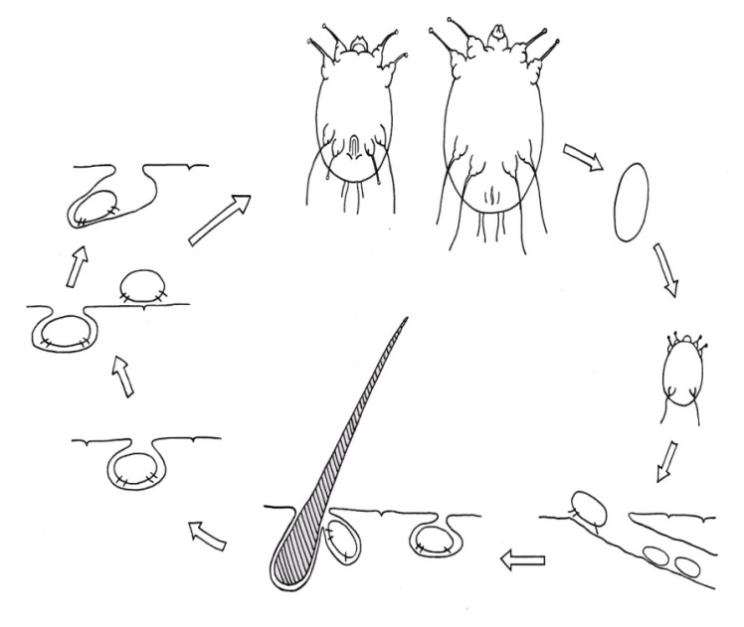

Egg

Larvaaa

2 nymphal stages

Inseminated female

Adults

Moulting pouch

Diagram of the lifecycle of scabies mite.

(Illustrated by C. Whitehorn).

Pathology

When an individual is first infested with *Sarcoptes* there is seldom any evidence of symptoms for the first month (2-6 weeks). Clinical symptoms arise only when patients have become sensitized to the mites. Once sensitized, and in all subsequent infestations, symptoms may occur rapidly (in 1-4 days). Scabies presents as a generalised rash with raised, itchy papules occurring at the site of each mite burrow. Intense itching is one of the most commonly reported symptoms particularly at night and over most of the body. Scratching leads to broken skin and the formation of pustules. The majority of burrows are found between the fingers and the toes, and at the bends of the knees and the elbows, but the skin of the scrotum, penis, knees, buttocks and breasts may also be affected. The scabies “rash” is a symmetrical allergic skin reaction that may appear on the body from the underarms down to the calves and around the waist, but not on the upper back. The location of this “rash” does not correspond to the location of the mites. In patients with a suppressed immunity a condition called crusted ‘Norwegian’ scabies may occur. In this situation the patient does not react to the mites in the skin and the mite population increases unchecked. The condition results in a scaly crusted skin and is highly contagious. In children and the elderly scabies may be atypical in that the face and scalp may be affected and burrows are seldom found.

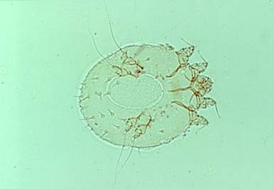

*Sarcoptes scabiei*

Photograph of female mite in slide preparation. **Note:** the large egg located between the hind legs.

© LSHTM

Diagnosis

The diagnosis of scabies is based on the appearance and distribution of the rash and by the presence of burrows. Where possible the diagnosis should be confirmed by isolation of mites, eggs or faecal pellets from a skin scraping. Examine the surface of the skin for burrows using a magnifying glass. Pay particularly attention to the hands, the webs between the fingers and the folds of the wrist. Apply a drop of mineral oil to the skin where there is evidence of a burrow. With a sterile scalpel blade gently scrape the horny layer of the skin and collect the scrapings into a fresh drop of oil on a microscope slide. Examine the preparation under the x10 objective.

*Demodex* species (the follicle mites)

Follicle mites inhabit the skin of most adults especially women and normally produce no ill effects. They are host specific and two species are found on man: *Demodex follicularum*,found in the hair follicles and *D. brevis*,found in the sebaceous glands. The entire lifecycle occurs in the follicles.

Description

*Demodex* speciesare extremely small mites (0.1- 0.4mm in length) and very atypical in that they have a worm-like appearance. The body is transversely striated and four pairs of stumpy legs are located anteriorly behind the mouthparts. The mites live head down in the follicles and sebaceous glands and feed on subcutaneous tissues and exudates. Infestations occur mainly in the facial area, the eyelids and the nose.

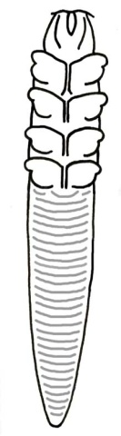

*Demodex* species

(Illustrated by C. Whitehorn).

Pathology

They can cause dermatitis in sensitised individuals and this may result in acne, rosacea, impetigo contagiosa or blepharitis.

Diagnosis

Express the contents of follicular pores around the naso-labial fold and smear on a microscope slide. Examine the preparation under the x40 objective.

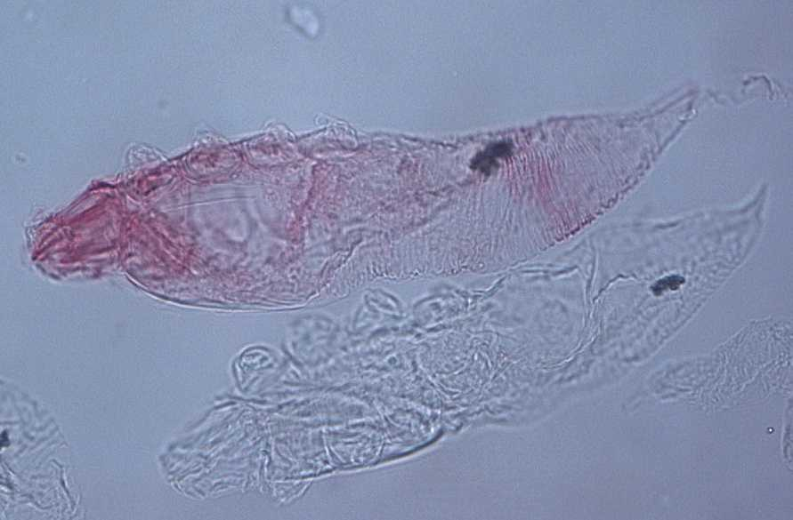

*Demodex* species

Photograph of mite in slide preparation at x 340 magnification. Condenser iris must be set at 1 for maximum contrast.

© LSHTM

Trombiculid mites (chigger/scrub typhus mites)

The larvae of trombiculid mites are parasitic on vertebrates and are known as chiggers, harvest bugs and scrub-itch mites. They can cause dermatitis in man and are vectors of ‘chigger-borne rickettsiosis’ (scrub typhus) in South-East Asia. The nymph and adult stages are free-living predators.

Description

The larvae are oval, creamy white to reddish-orange in colour and are very small (0.15-0.3mm long). They have three pairs of legs which terminate in a pair of large claws. The palps and mouthparts are large and conspicuous and give the appearance of a head. The legs and the body are covered in fine feathered hairs. A dorsal shield (termed a scutum) can be seen on the anterior part of the body and from this a number of setae arise.

Lifecycle

Female mites lay eggs in leaf litter or damp soil. The eggs hatch after a week or so, but the larvae remain within the eggshell for a further 5-7 days before emerging. The hexapod larvae climb on to passing birds or mammals and then search for a suitable site to feed. Feeding lasts 2-10 days on man and then the engorged larvae drop to the ground, bury themselves in the soil and moult to become 8-legged protonymphs. The protonymph is a dormant stage and about one week later it moults to the deutonymph; a free living stage that feeds on soil animals. The deutonymphs are active for about 2 weeks and then undergo a further dormant period (the tritonymph) prior to the moult to the adult stage. The entire lifecycle typically takes 40-75 days.

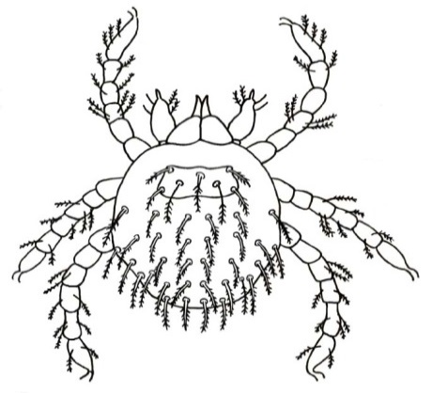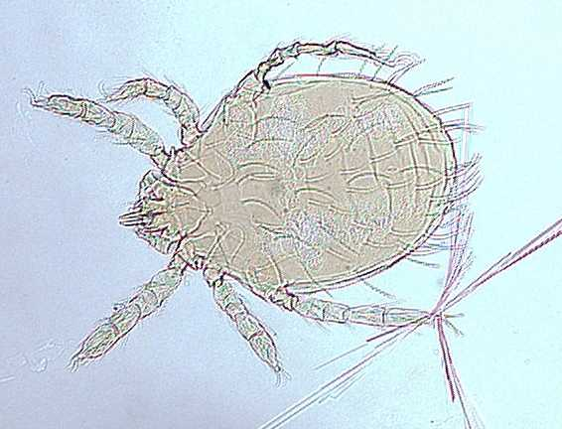

Diagram of a trombiculid mite (larva)

(Illustration by C. Whitehorn)

*Leptotrombidium akamushi* – larva Photograph of a scrub typhus vector from Japan. © LSHTM

Pathology

The larvae attach to the skin of the host with their powerful mouthparts and inject saliva to the dermal tissues. The saliva digests these tissues and they are ingested by the larva. The repeated injection of saliva leads to the formation of a feeding tube that extends vertically in the host’s skin. The bites cause an intense itchy dermatitis leading to pustules and wheals a few hours after exposure. This condition is known as ‘harvest bug itch’ or ‘scrub itch’. Throughout Asia these mites are vectors of Rickettsia tsutsugamushi the causative agent of ‘chigger-borne rickettsiosis’, also known as scrub typhus. In cases where the mite is infected the bite is not painful, but an eschar is formed at the site of attachment. An eschar is a firm, black adherent scab 3-6mm in diameter and surrounded by a fine red margin. The symptoms of ‘chigger-borne rickettsiosis’ are typical of other forms of typhus and include fever and painful lymph nodes.

Diagnosis

Diagnosis is based on the location and presentation of lesions (stylostomes) on the skin surface. Mites particularly attach around the waist and genitals of man. Where mites are present on the host removal may be difficult, and great care should be taken when obtaining a sample for microscopy. Any material collected from the patient should be suspended in Berlese’s fluid on a microscope slide and examined under the x10 objective for the presence of mites. Set the condenser iris at 1 for maximum contrast. Travel history may also be useful for diagnosis.

*Dermanyssus gallinae* (the chicken mite)

Commonly known as the red poultry mite or chicken mite *Dermanyssus gallinae* is a parasite of poultry and wild birds, and is cosmopolitan in distribution. In the absence of primary hosts (that is, when birds fledge and leave the nest) the mites will actively seek new hosts and will bite man.

Description

Unfed mites are roughly 0.7mm in length and grey in colour. They tend to feed at night and enlarge to become bright-red mites about 1.0mm in length. They have well developed legs and a large capitulum.

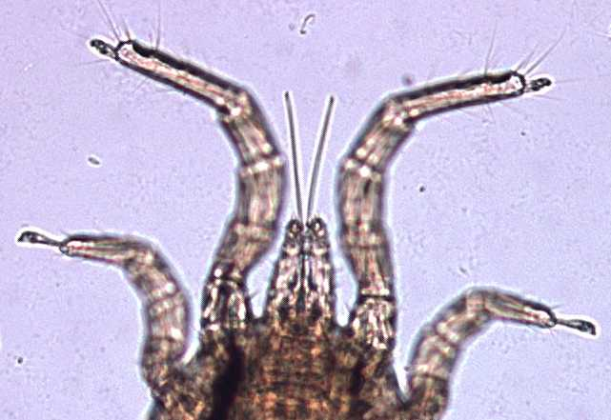

*Dermanyssus gallinae*

Photograph of anterior body.

© LSHTM

©

The chelicerae are long, whip-like and taper apically, but are very fragile and can be broken during specimen processing. The dorsal body surface has one shield. The anal shield on the ventral surface is cup shaped.

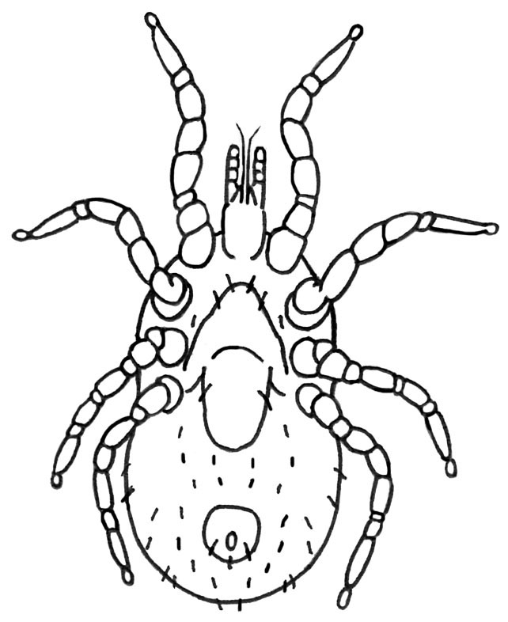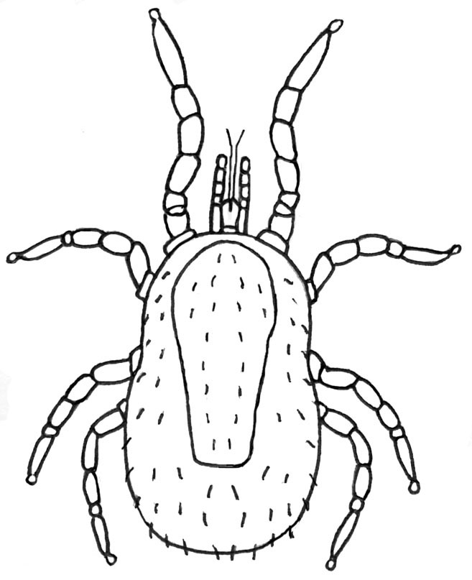

*Dermanyssus gallinae*

Diagram of dorsal surface of female mite.

(Illustration by C. Whitehorn)

*Dermanyssus gallinae*

Diagram of ventral surface of female mite.

(Illustration by C. Whitehorn)

Lifecycle

The eggs are deposited in the nesting material of the host and the cracks and crevices of the roost site. The lifecycle is extremely rapid and may be completed in one week given optimum conditions. Domestic infestations in houses, hospitals and tube stations can occur and are normally found to originate from abandoned nest sites.

Pathology

The bites of *D. gallinae* are painful and irritating.

Diagnosis

The mites are visible to the naked eye and may be collected from the host or from resting sites in the environment (cracks and crevices in furniture or walls). Chicken mites require a period of clearing in lactophenol prior to mounting for identification.

Ticks1,2,10,11

Ticks (subclass: Acari) are arachnids (class: Arachnida) and as such have a fused body that shows no division into head, thorax and abdomen. The body bears eight legs in the adult stages.

Ticks are obligate parasites of vertebrate hosts and have a high economic impact as ectoparasites of livestock and vectors of disease to animals and man9. Many will feed opportunistically on man and may be responsible for the transmission of zoonotic viral, rickettsial, bacterial and protozoal infections.

Refer to: Lane and Crosskey for keys to the families and genera of ticks and Hillyard (entire book) for keys to the ticks of North-West Europe1,11.

**Description**

Ticks normally range in size from 1-30mm. The body is covered in a tough leathery integument. There is no division of the body into head, thorax and abdomen, but the capitulum (the structure that bears the mouthparts) is conspicuous and may be confused with a head. Ticks are generally larger than mites, but this is not a reliable character to distinguish the two groups. The presence of the toothed hypostome (median part of mouthparts) and the Haller’s organ (on the tarsi of the first pair of legs) clearly distinguish ticks from mites.

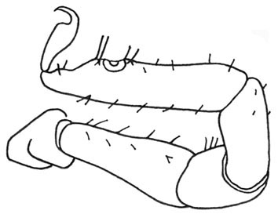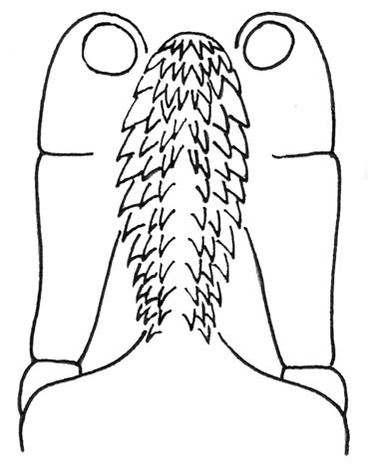

Diagram of ventral view of tick capitulum to show the basis capituli, the toothed hypostome (arrowed) and the palps.

(Illustration by C. Whitehorn)

Diagram of tick foreleg to show Haller’s organ (arrowed), a sensory organ.

(Illustration by C. Whitehorn)

Hypostome

Haller’s organ

Ticks demonstrate an incomplete lifecycle with the adults, nymphs and larvae occupying similar ecological niches. Adults and nymphs have eight legs, but larval ticks only have six legs. Larval stages could be confused with insects but for their lack of body division. There are two main families of ticks: the soft ticks (family: Argasidae) and the hard ticks (family: Ixodidae).

Soft ticks – *Argasidae*10

The soft ticks typically have an oval body shape and range in size from 4-15mm. They have a tough leathery integument that may be mammillated or granular in appearance. The mouthparts are located ventrally on the body surface and are therefore not visible from above. The lack of a scutal shield and the ventral location of the mouthparts help to distinguish soft ticks from hard ticks. There is little sexual dimorphism in soft ticks.

**Lifecycle**

The soft tick lifecycle is slightly more complex than that of the hard tick with a greater number of nymphal stages and longer life expectancy in adults. Eggs hatch to give a six-legged larva, the larva moults to give the eight-legged nymph (there can be 2 to 8 nymphal stages dependant on species). The nymph then moults to give the eight-legged adult. Soft ticks take more blood meals than hard ticks and over much shorter durations (15 – 120 minutes) so that they are seldom found attached to patients. Larvae take only one blood meal, but each nymphal stage and the adults will take two or more blood meals. Soft ticks are known as one-host ticks because they are normally associated with a single host species throughout their lifecycle. Females will lay a small batch of eggs after each blood meal and may live for over a decade. Soft ticks spend at least 99% of their time off the host. They are particularly resistant to desiccation and starvation and will enter a state of torpor to survive adverse conditions.

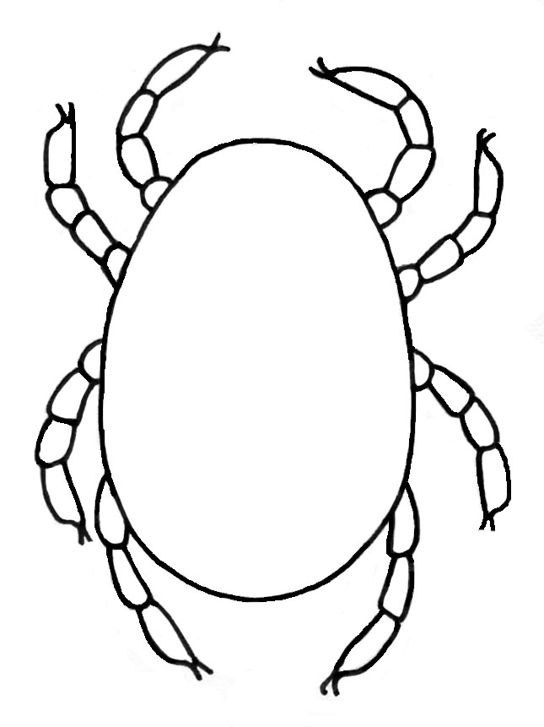

Dorsal view of a soft tick.

(Illustration by C. Whitehorn)

Medically important soft ticks

The soft ticks of medical importance are *Ornithodoros, Otobius* and *Argas.*

*Ornithodoros*

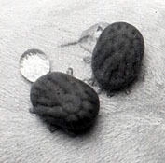The genus *Ornithodoros* contains a number of species that are serious nuisance biters of man and seven species that are known to transmit tick-borne relapsing fever. Members of the genus can be recognised by their dark mammillated cuticle and absence of a distinct lateral line between the dorsal and ventral body surfaces. *Ornithodoros moubata* is probably the most important vector of tick-borne relapsing fever in tropical Africa but the disease is also found in South and Central America.

*Ornithodoros moubata* Vector of relapsing fever.

© LSHTM

*Otobius*

*Otobius megnini* (the spinous ear tick) is primarily an ectoparasite of cattle and horses but will opportunistically attack man. The preferred site of attachment for the larva and nymph is the ear cavity and nymphs may remain attached for several months. The nymph ranges in size from 4 - 8mm and can be recognised by the presence of thick, dark spines over the body surface. The cuticle lacks a distinct lateral line between the dorsal and ventral body surfaces. *Otobius* is restricted to the hot arid areas of the Americas, Africa and India. Adult *Otobius* species ticks are non-feeding.

*Argas*

Members of the genus *Argas* are of worldwide distribution and are primarily associated with birds. These ticks will attack man opportunistically and have particularly painful bites. All life stages (larva, nymph, adult) may bite man but the larval Argas will remain attached to their host and continue to feed over a number of days. The body of the tick is slightly flattened with the dorsal and ventral body surfaces separated by a clear band of flattened rectangular cells.

Refer all soft ticks to a reference facility for identification.

Hard ticks – *Ixodidae*10

The hard ticks are recognised by the presence of a scutum, mouthparts that are visible from the dorsal surface, and marked sexual dimorphism in the adults. The scutum is an inflexible plate that lies on the dorsal surface of the body. It may bear a colourful pattern in some species. In males the scutum covers the entire dorsal surface but in females and immature stages it only covers the anterior part of the body (to allow full engorgement during feeding). Females are distinguished from nymphs by the presence of a genital aperture on the ventral surface and porose areas on the basis capituli (see photograph on page 39).

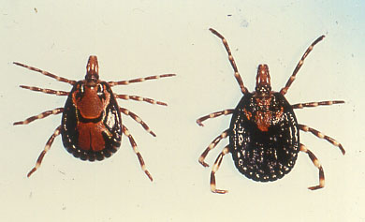

*Amblyomma variegatum*

Photograph of male and female.

© LSHTM

Lifecycle

The hard tick lifecycle is relatively simple with egg hatching to six-legged larva, larva moulting to eight-legged nymph and nymph moulting to eight-legged adult. Each stage requires a single feed before progressing to the next but it can take a number of years to complete the entire lifecycle. Hard ticks feed slowly and remain attached to the host for several days. Ixodids are often known as multi-host ticks because they are normally associated with two or three host species throughout their lifecycle (that is, larva – mouse, nymph – rabbit, adult – sheep). Females produce a single egg mass in their lifetime and die shortly afterwards. Hard ticks spend at least 90% of their time off the host resting and undergoing development. They are very sensitive to desiccation and extremes of temperature.

Medically important hard ticks

Members of the genus ***Ixodes*** are known to be vectors of Lyme disease in the UK11. Two of the most commonly referred species are ***Ixodes ricinus*** and ***Ixodes hexagonus.*** The genus can be identified by examining the anal groove on the ventral surface of the tick11.

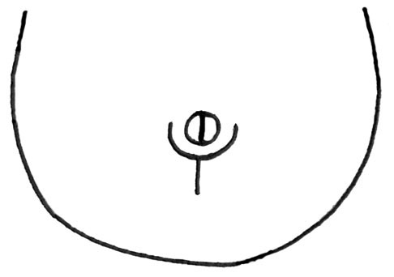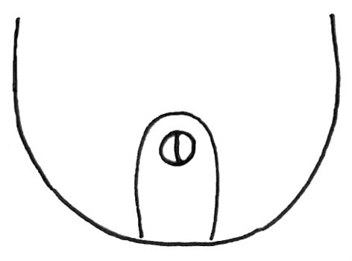

Diagram of the anal groove of ticks belonging to the genus *Ixodes*.

(Illustration by C. Whitehorn).

Diagram of the anal groove of all other hard tick genera.

(Illustration by C. Whitehorn)

anal groove

For *Ixodes* the anal groove circles the anus anteriorly. For all other hard tick genera the anal groove circles the anus posteriorly.

If the patient has been bitten by a British tick of another genus there is little risk of disease transmission.

Refer any non-*Ixodes* species and all ticks acquired overseas to the appropriate reference facility for identification.

Lyme disease12

Lyme disease is a bacterial infection caused by the spirochaete *Borrelia burgdorferi*. It is a zoonotic infection associated with woodland and heath land habitats. The main reservoir hosts are rodents (wood mice and voles) and the deer population. In unfed ticks the spirochaetes are restricted to the midgut and only migrate to the salivary glands once feeding is initiated. Therefore swift removal of ticks (within 24-48 hours of attachment) is an important factor in reducing the risk of disease transmission.

Tick paralysis

Tick paralysis is caused by the inoculation of a neurotoxin (within the saliva) into the host as a female tick feeds. A number of hard tick species are known to cause this condition, but none are native to the UK. Five to seven days after attachment the host may develop fatigue, numbness and muscle pain. This may rapidly progress toward partial paralysis, convulsions and respiratory failure unless the attached tick is located and carefully removed. Symptoms will persist as long as any part of the tick’s mouthparts remain in the host.

Removal of ticks

Forcible removal of ticks often results in damaged mouthparts and the risk that material is left embedded in the skin of the patient. Mouthparts also provide important characters for the identification of ticks so using the correct removal technique is vital. Take a pair of fine forceps and gently (but firmly) grasp the mouthparts of the tick as close to the patient’s skin as possible. Rotate the mouthparts slightly whilst pulling the tick away from the skin. A firm but gentle action should result in the removal of the tick without harm to either party. Transfer the tick to a sterile tube and refer for identification. Clean and disinfect the wound site and sterilize the forceps. Monitor the wound site over the next few days for any developing erythema.

Preparation of material

Ticks should be killed in hot water (85°C) and preserved in 70% ethanol. Adult ticks should be examined under a dissecting microscope, but temporarily removed from the ethanol and examined dry. Body features are more clearly visible as the ethanol evaporates. Nymphs and larvae should be slide mounted in Hoyer’s medium and examined under a compound microscope. Hoyer’s medium consists of 50mL distilled water, 30g crystalline gum Arabic, 200g chloral hydrate and 20mL glycerine9.

The life stages

Keys for the identification of ticks are written for each of the life stages; larva, nymph, male and female. External characters may vary considerably among the life stages even within the same species. It is therefore crucial that the life stage is identified correctly before attempting to key out the specimen any further.

Life stages of soft ticks

As previously stated there are only minor morphological differences between the life stages of the soft ticks. Larvae are distinguished by having only six legs, the nymphs by having eight legs and lacking a genital aperture, and the adults by having eight legs and possessing a genital aperture. In the adults the genital aperture is located on the ventral surface, below the mouthparts, along the midline between coxae 1 and 2. In females it appears as a horizontal slit and is often strongly marked. In males the genital aperture is oval and less clearly defined.

Life stages of hard ticks

Although there are greatermorphological variations among the life stages of the hard ticks it is still necessary to examine specimens with care. This is particularly important when differentiating between the nymph and the female hard tick. The larval stage is distinguished by having only six legs and the nymph by having eight legs and lacking a genital aperture. Adults have eight legs and possess a genital aperture. The genital aperture is located on the ventral surface of the body, over the midline, between coxae 3 and 4. The sexes are differentiated by the size of the scutal shield; the scutum completely covers the dorsal surface of the body in male ticks but only covers the anterior part of the body in female hard ticks. Confusion often arises between the nymph and the female stage because they both have a reduced scutum and eight legs, so in addition to the genital aperture another character to look for are the porose areas on the dorsal basis capitulum. These are absent in nymphs but present in the females.

Diagrams of the life stages of hard ticks. Dorsal view.

(Illustrated by C. Whitehorn)

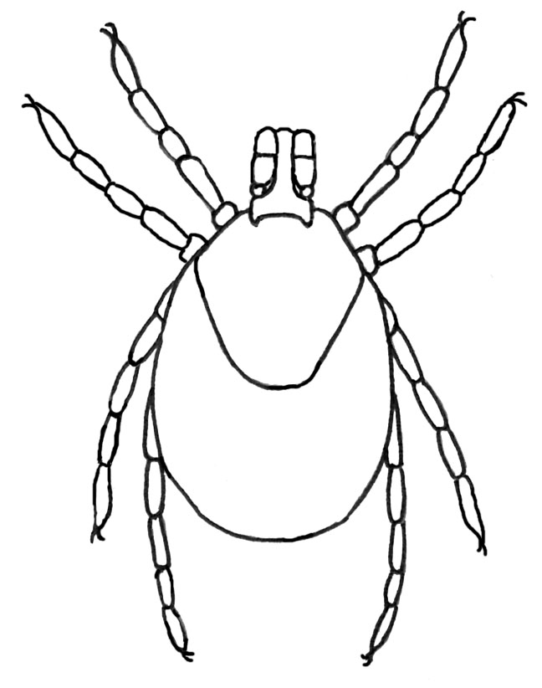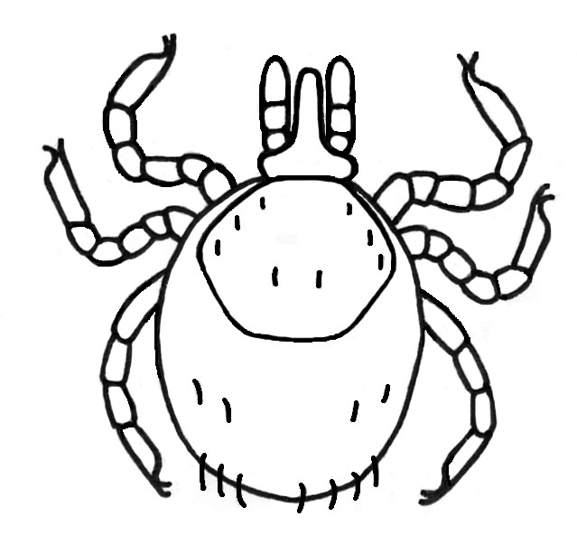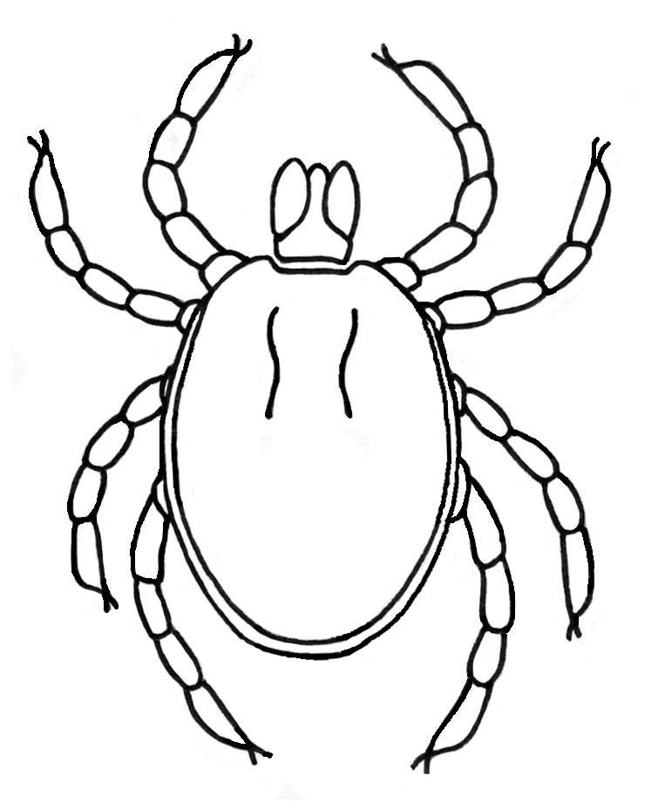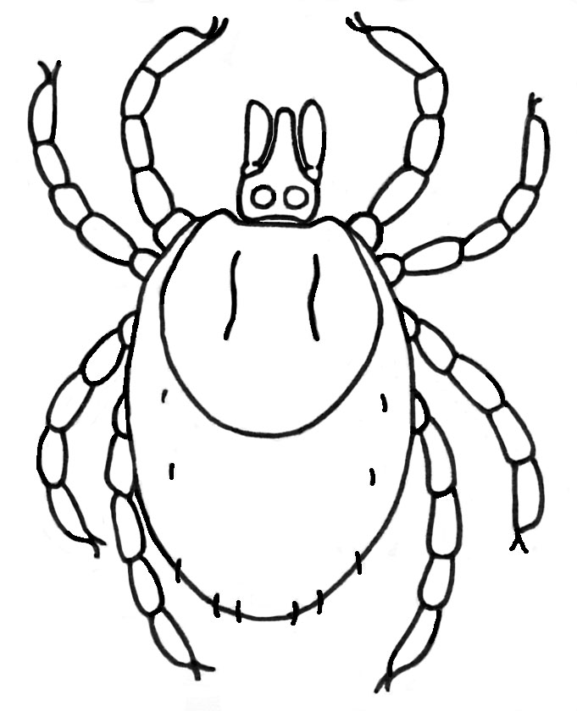

Larva

Nymph

Male Female

Porose areas

Two depressions located on the dorsal surface of the basis from which the females produce secretions to lubricate and protect the egg mass. The porose areas can merge to form a single depression in some species of hard ticks.

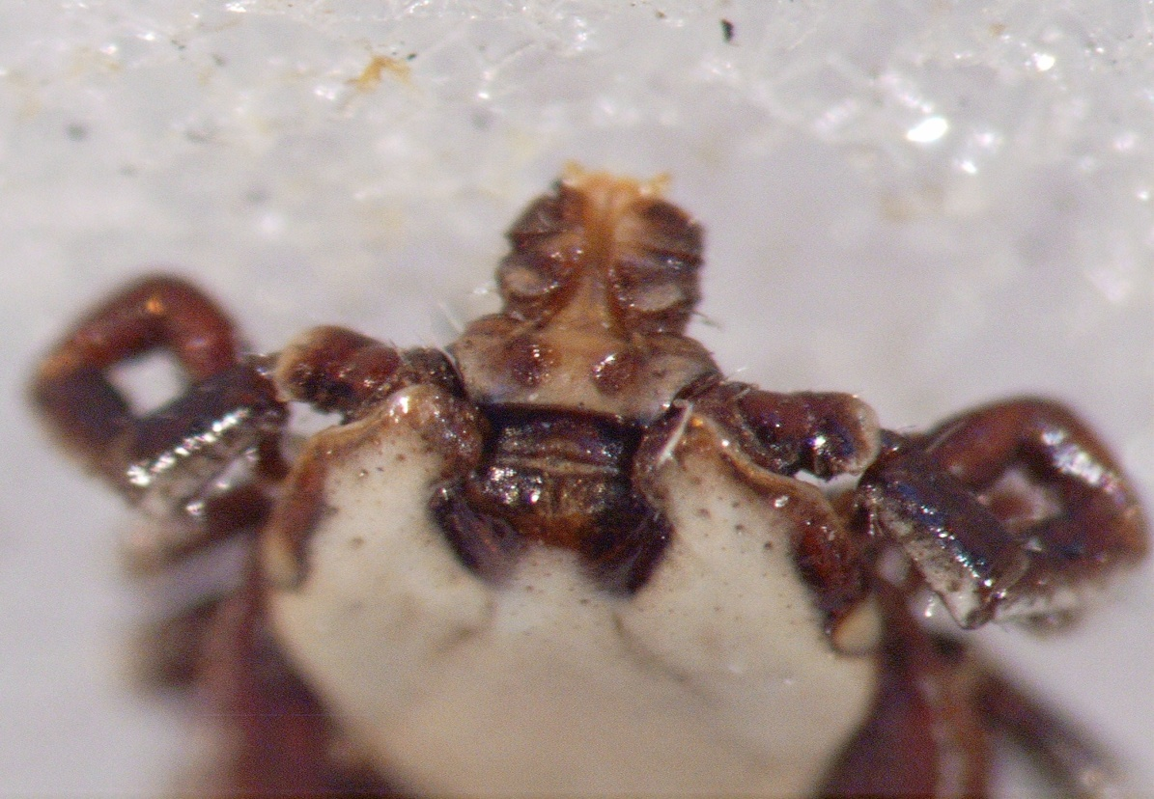

*Rhipicephalus pulchellus.*

Photograph of female to illustrate the porose areas on the basis capitulum.

© LSHTM

Of all the tick specimens that are referred for identification the hard tick *Ixodes ricinus* is the most common. On the following pages are descriptions of all the life stages of   
*Ix. ricinus* and of *Ix*. *hexagonus* (another commonly referred species) for your information*.*

*Ixodes ricinus* (common sheep tick, castor bean tick or wood tick)10

This tick is distributed throughout North-West Europe and most of the western Palaearctic, it is most abundant in the sheep pastures of the British Isles.

Description

A brief description is given for all life stages but the nymph and the adult female are most commonly sent for identification. Please refer to P. Hillyard (pg 74-76) for illustration of the structures listed below11. The description of the larva is taken from Arthur10.

Larva

Length of unfed larva approximately 1mm. The larval stage has only 3 pairs of legs and the scutum only partially covers dorsal surface of body. The palps (segments 2 and 3) are longer than the width of the basis capituli. The denticles on the hypostome are arranged in two or three rows of 3/3 distally, then six or seven of 2/2. The auriculae (structures on the ventral surface of the basis) appear as distinct projections. The scutum is wider than long and roughly hexagonal in shape. Coxae 1 to 3 have distinct external spurs and coxa 1 has a small internal spur.

Nymph11

Length of unfed nymph 1.3–1.5mm. The nymph has four pairs of legs, the scutum only partially covers dorsal surface of body and there is no genital pore on the ventral surface. The palps (segments 2 and 3) are longer than the width of the basis capituli. The scutum is almost circular in shape, the auriculae (structures on the ventral surface of the basis) resemble divergent triangles, and coxa 1 (the first segment of the first leg) has an internal spur (pointed outgrowth on coxa) longer than the external spur.

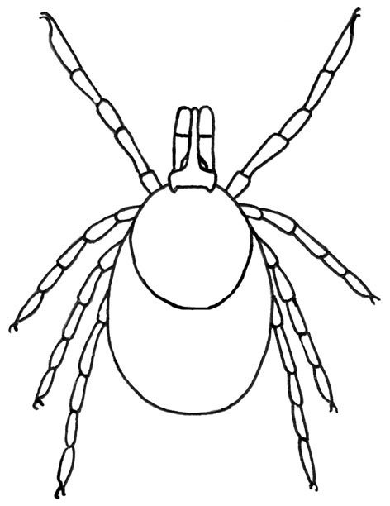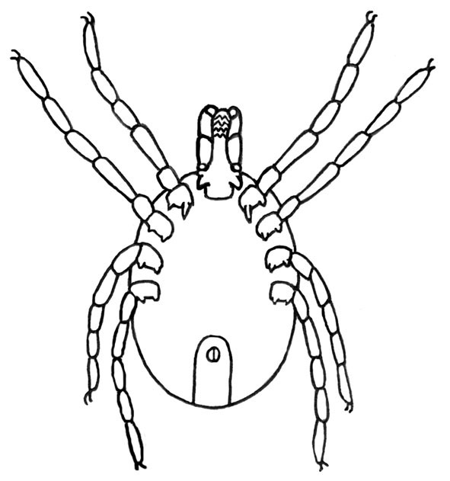

Diagram of ventral surface of *Ixodes ricinus* nymph.

(Illustration by C. Whitehorn).

Diagram of dorsal surface of *Ixodes ricinus* nymph.

(Illustration by C. Whitehorn)

Adult Male11

Length of male 2.4–2.8mm. The scutum covers dorsal surface of the body. The palps are short and broad. The hypostome has prominent teeth. The internal spur of coxa 1 is three times longer than external spur. Tarsus 1 (in profile) tapers gradually.

Adult Female11

Length of unfed female 3.0–3.6mm. The scutum partially covers dorsal surface of the body, a genital pore is present on the ventral surface and two porose areas are present on the dorsal basis capituli. The palps (segments 2 and 3) are longer than the width of the basis. The scutum is a little longer than wide and broadly rounded posteriorly. Auriculae are absent. Coxa 1 has a long internal spur. Tarsus 1 (in profile) tapers gradually. The genital aperture is located between coxae 4.

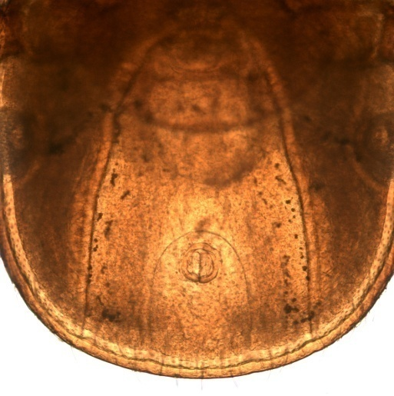 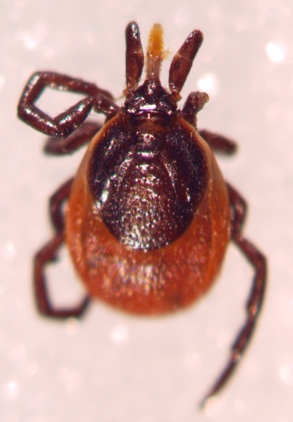

Ventral view of *Ixodes ricinus* female Dorsal surface of an *Ixodes*

to show anal and genital grooves. *ricinus* female (unfed)

© LSHTM © LSHTM

*Ixodes hexagonus* (hedgehog tick)10

Distributed widely throughout Western Europe this tick is a parasite of hedgehogs, foxes, badgers and dogs. *I. hexagonus* frequently bites man.

Description

A brief description is given for all life stages but the nymph and the adult female are most commonly sent for identification. Please refer to P. Hillyard for illustrations of the structures listed below11. The description of the tick larva is taken from Arthur10.

Larva

Length of unfed larva approximately 1mm. The larval stage has only 3 pairs of legs and a scutum that only partially covers the dorsal surface of the body. The palps (segments 2 and 3) are approximately equal in length to the width of the basis capituli. The denticles on the hypostome are arranged in two or three rows of 3/3 distally, and then about four rows of 2/2. The auriculae are represented as thickened ridges. The scutum is usually wider than long and heart-shaped. Coxa 1 has a broad internal spur but no other spurs are present.

Nymph11

Length of unfed nymph 1.2–1.4mm. Nymph has four pairs of legs, the scutum only partially covers dorsal surface of body and there is no genital pore on the ventral surface. The palps (segments 2 and 3) are slightly shorter than the width of the basis capituli. The scutum is longer than wide and hexagonal in shape. No auriculae are present. The internal spur on coxa 1 is short, external spurs on coxae 1-4 are reduced or absent.

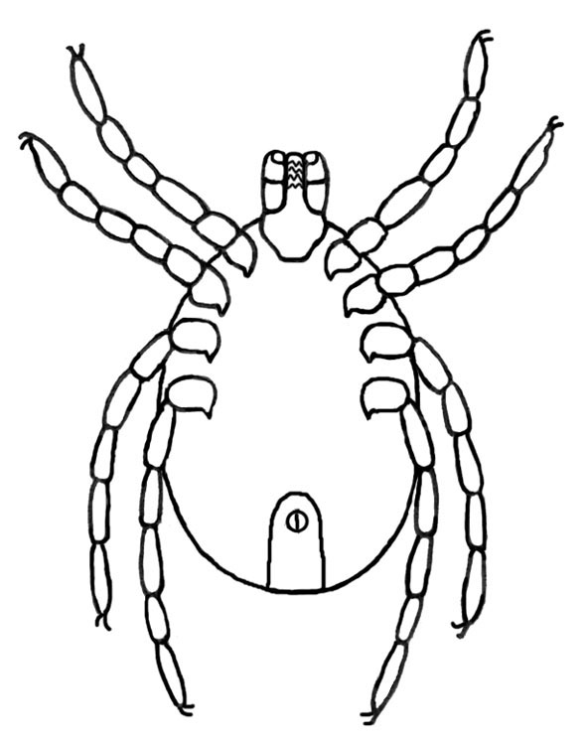

Diagram of dorsal surface of *Ixodes hexagonus* nymph

(Illustration by C. Whitehorn)

Diagram of ventral surface of *Ixodes hexagonus* nymph

(Illustration by C. Whitehorn)

Adult male11

Length of male 3.5–3.8mm. The scutum covers dorsal surface of body. The body is broadly oval in shape. The palps are short and broad and the hypostome is almost toothless. The internal spur on coxa 1 is long. Tarsus 1 (in profile) is clearly stepped near apex.

Adult female11

Length of unfed female 3.5–4.0mm. The scutum partially covers the dorsal surface of the body, the genital pore is present on the ventral surface and two porose areas are present on the dorsal basis capituli. The palps (segments 2 and 3) are slightly shorter than the width of the basis. The scutum is characteristically heart or hexagonal in shape. The auriculae are vestigial. Coxa 1 has a long internal spur. Tarsus 1 (in profile) is clearly stepped near apex. The genital aperture is located between coxae 3.

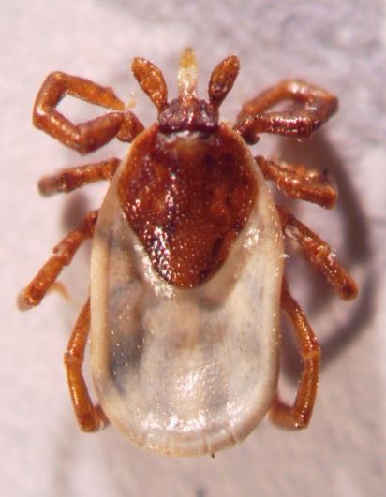

Dorsal surface of an *Ixodes*

*hexagonus* female (part fed).

© LSHTM

Maggots2

Myiasis maggots2,3

Myiasis is caused when fly maggots (dipterous larvae) invade living vertebrate animals to feed on living tissue, necrotic tissue, body fluids or the ingested food of the host13. Myiasis causing flies are either obligate or facultative parasites in their larval stages: the former must develop on or in a living host, the latter can also develop on decaying organic matter. The facultative parasites may be primary, secondary or tertiary invaders of vertebrate animals depending on their ability to attack hosts. Primary invaders initiate myiasis, but secondary and tertiary invaders only attack the host once myiasis has been initiated by other species. However it should be noted that primary invaders (such as the greenbottle *Lucilia sericata*) always require a predisposing condition such as a wound or poor hygiene to stimulate oviposition. They will not initiate myiasis on clean, healthy animals.

A condition known as pseudomyiasis may occur when the larvae or eggs of certain species are accidentally ingested and pass living through the gut of the host.

Description

The myiasis maggots do not have a uniform appearance because they are drawn from a large number of dipteran families. However, those of principal medical importance exhibit two main body shapes; the classic wedge-shaped maggot and the more rounded grub-like maggot. The body is divided into 12 segments, the first being the head, the next three the thorax and the last eight the abdomen. However, there is little differentiation between the segments. The first segment contains the cephalopharyngeal skeleton (the mouth parts) and this has important taxonomic characters for identification. The second segment bears a pair of anterior spiracles which link via two tracheal trunks to the posterior spiracles on the 12th (terminal) body segment. The spiracles and tracheae are the respiratory apparatus of the maggot and also provide useful characters for identification. Myiasis maggots do not have legs, but some species have body swellings, spines and processes that aid in locomotion and prevent dislodgement from the host.

Medically important myiasis maggots

The genera that are principally referred for identification in the UK are *Lucilia* (greenbottles), *Calliphora* (bluebottles), *Oestrus* (sheep nasal bot-fly) and *Sarcophaga* (flesh flies)14. *Cordylobia* (Tumbu fly and Lund’s fly) and *Dermatobia* (human bot-fly) are both tropical genera that are occasionally seen in overseas travellers returning to the UK. There are a number of other genera that are serious agents of myiasis and many more that are of minor medical importance. This UK SMI will examine only those genera that are commonly referred for identification. All the descriptions included are for third instar larvae, except for *Oestrus ovis* where the first instar larva is described. Refer to Lane and Crosskey for keys to the families and genera of myiasis maggots1.

Preparation of material

Myiasis maggots should be killed by immersion in hot or boiling water (90-100°C) for 15-30 seconds and then stored in 80% ethanol prior to preparation. Take the maggot and slice off the last segment that bears the posterior spiracles. Place the segment and the body into a test tube containing 5% Potassium hydroxide (KOH), transfer to a water bath and slowly heat to boiling point. Remove from heat and allow the contents to cool for 10 minutes. Wash the body and posterior segment well in water (two changes of about 5 minutes each). Transfer the maggot body to a glass slide and begin to squeeze the body contents out from the cuticle. It may be necessary to repeat the KOH boiling stage two or three times to extract all the body tissues. Dehydrate the body cuticle and the posterior segment through increasing strengths of ethanol (70%, 90% and absolute) for five minutes each. Repeat in fresh absolute alcohol for five minutes before transferring to Cellosolve (2-ethoxyethanol) for a final five minutes. Mount the specimen directly in euparal in the centre of a microscope slide. The body cuticle should be placed laterally on the upper half of the slide and the posterior segment below (outer cuticle uppermost). Add a coverslip and carefully examine the specimen. The slide specimen should be placed into an oven for 4-6 weeks at 55°C to give a permanent preparation. Label the slide with the identification, reference number and collection data.

*Lucilia* – greenbottles

Greenbottles are cosmopolitan in distribution. Female flies lay their eggs in neglected wounds and on soiled fabrics. The larvae feed directly on the tissues or on necrotic slough. Females will also deposit eggs on raw and cooked meats or fish and if this is ingested intestinal myiasis may occur7.

**Description:** Maggots of the genus *Lucilia* have the classic “maggot” form with a narrow anterior segment bearing the mouth-hooks broadening out to a truncate posterior segment.

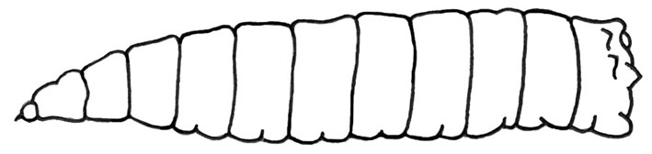

*Lucilia* species.

Diagram of third instar larva.

(Illustration by C. Whitehorn)

A mature larva is about 14mm long and white to cream in colouration. The posterior spiracles are located on the face of the terminal segment and each consists of three straight slits surrounded by a closed peritremal ring with a distinct button.

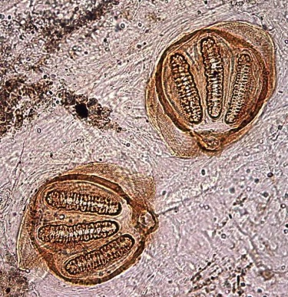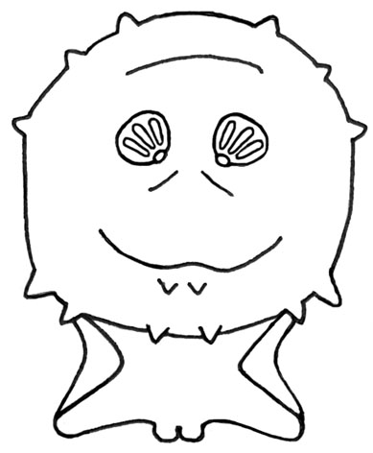

*Lucilia* species.

Posterior view of terminal segment of third instar larva.

(Illustration by C. Whitehorn)

*Lucilia* species.

Photograph of posterior spiracles.

© LSHTM

There is no accessory oral sclerite (a small additional sclerite) present between the mouth-hooks.

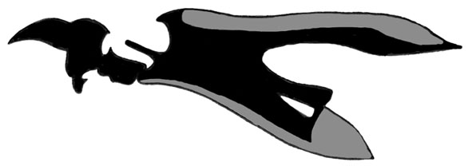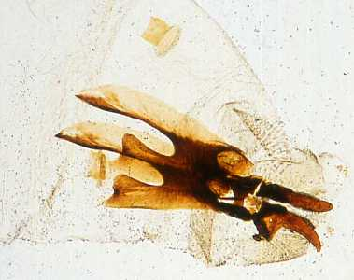

*Lucilia* species.

Diagram of cephalopharyngeal skeleton. **Note:** Lack of accessory oral sclerite between mouth-hooks.

(Illustration by C. Whitehorn)

*Lucilia* species.

Photograph of anterior segments to show skeleton, cephalopharyngeal and anterior spiracles.

© LSHTM

*Calliphora* – bluebottles

Bluebottles are cosmopolitan in distribution. Female flies typically lay their eggs on decaying organic matter and normally attack man only as secondary invaders. Females will also deposit eggs on fresh meat and if that is ingested an intestinal myiasis may occur.

Description

Maggots of the genus *Calliphora* are slightly larger than those of *Lucilia* but have an identical body shape and colour. A mature larva is about 17mm long. The posterior spiracles are located on the face of the terminal segment and each consists of three straight slits surrounded by a closed peritremal ring with a distinct button. *Calliphora* species are distinguished from *Lucilia* species by the presence of an accessory oral sclerite between the mouth hooks.

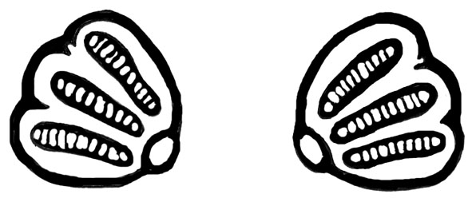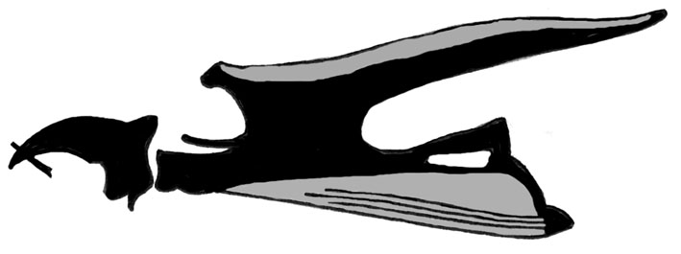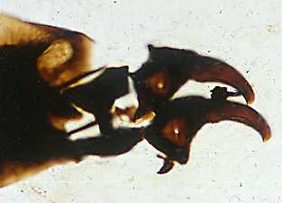

*Calliphora* species. Photograph of cephalopharyngeal skeleton.

**Note:** presence of accessory oral sclerite between mouth-hooks.

© LSHTM

*Calliphora* species. Diagram of cephalopharyngeal skeleton.

**Note:** accessory oral sclerite between mouth-hooks.

(Illustration by C. Whitehorn)

Posterior spiracles of *Calliphora* species. (Illustration by C. Whitehorn)

(

Cordylobia anthropophaga – The Tumbu fly

The Tumbu fly occurs throughout sub-Saharan Africa. Female flies lay their eggs on damp sandy soil or on clothing hanging in the shade to dry (sites soiled by sweat, faeces or urine are particularly favoured). The larvae emerge after 2 days and, when triggered by the presence of a host, burrow into the subcutaneous tissues. The larvae remain within the dermis and each forms a distinct boil-like swelling. There are 3 larval instars and these take 8 -12 days to complete. The mature larva emerges from the “boil” and falls to the ground to pupate.

Description

Maggots of the genus *Cordylobia* have a grub-like appearance being fleshy and rounded at both ends. A mature *C. anthropophaga* larva is approximately 12mm long and 5mm wide. The third to eleventh segments of the body are densely covered with small spines. The posterior spiracles are located on the face of the terminal segment. Each spiracle consists of three moderately sinuous slits that are not surrounded by a peritremal ring but do have a faint button.

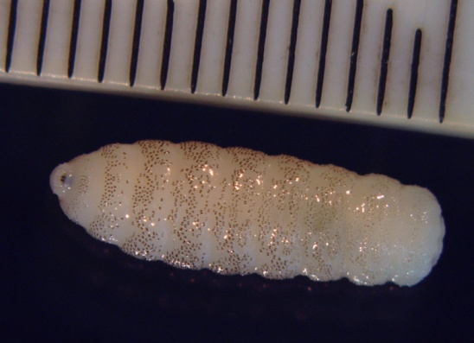

*Cordylobia anthropophaga*

Photograph of third instar larva with scale in millimetres.

© LSHTM.

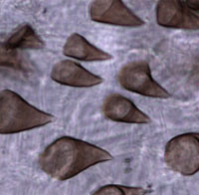

Spines on the cuticle of *Cordylobia.*

© LSHTM

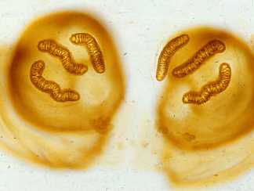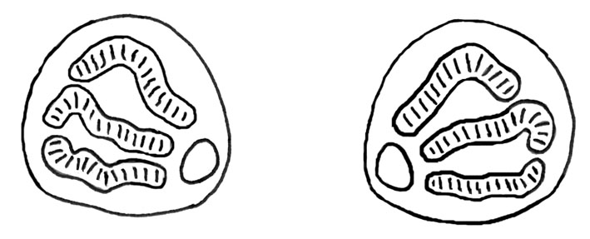

*Cordylobia anthropophaga* Photograph of posterior spiracles.

© LSHTM

*Cordylobia anthropophaga*

Diagram of posterior spiracles of third instar larva.

(Illustration by C. Whitehorn).

Cordylobia rodhaini – Lund’s fly

Lund’s fly occurs in the rainforest areas of tropical Africa and is very similar in appearance and lifecycle to the Tumbu fly.

Description

The maggot has a grub-like appearance and a mature *C. rodhaini* larva is 17-33mm long and 8mm wide. The body is covered in numerous large spines. The posterior spiracles are located on the face of the terminal segment.

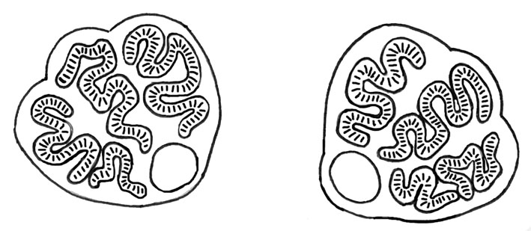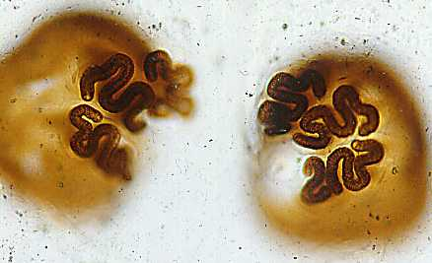

*Cordylobia rodhaini*

Diagram of posterior spiracles of third instar larva.

(Illustration by C. Whitehorn)

*Cordylobia rodhaini*

Photograph of posterior spiracles of third instar larva. © LSHTM

Each spiracle consists of three long serpentine slits that are not surrounded by a peritremal ring but do have a faint button.

*Dermatobia hominis* – the human bot-fly

The human bot-fly occurs throughout Central and South America. Female flies deposit batches of eggs on mosquitoes and other biting flies, or even ticks. These “couriers” then locate a host and as they feed, the bot-fly eggs (stimulated by the host’s temperature and odours) hatch. The larvae burrow into the skin of the host and each forms a distinct boil-like swelling. There are three larval instars and these take 6-12 weeks to complete. The mature larvae then emerge from the “boil” and fall to the ground to pupate. The “boils” are painful for short periods during larval feeding, and are less tender during developmental periods. The discharge of fluids (larval faeces and the host’s body fluids) from the wound may provide an attractive oviposition site for other myiasis flies.

Description

The maggot has a characteristic “pear-shaped” appearance with a swollen anterior end and a narrow posterior end. The body shape makes it particularly difficult to dislodge when embedded in the host. A mature larva is about 20mm long and 8mm at the widest part. The anterior and central segments bear numerous spines. The posterior segments have no spines but small denticles are present on the terminal segment. The posterior spiracles are recessed into a cavity on the terminal segment and consist of three straight slits with no peritremal ring and no button.

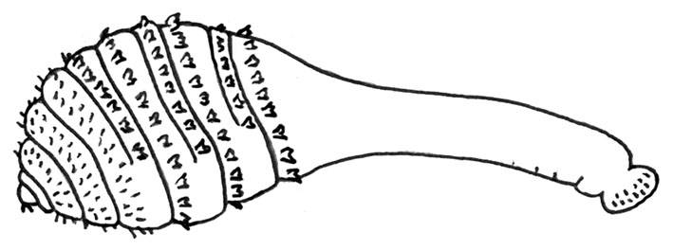

*Dermatobia hominis*

Diagram of second instar larva.

(Illustration by C. Whitehorn)

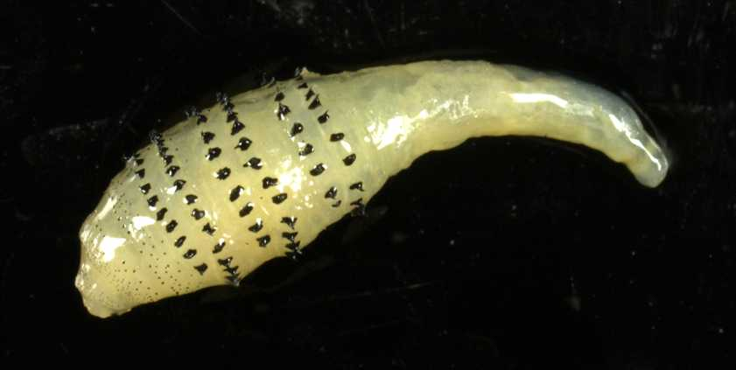

*Dermatobia hominis*

Photograph of second instar larva.

© LSHTM

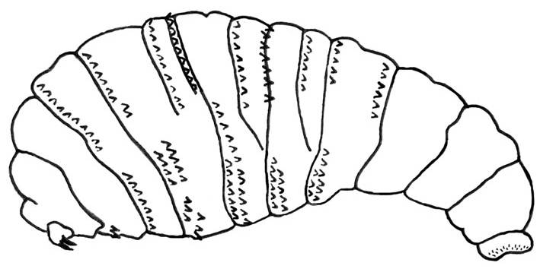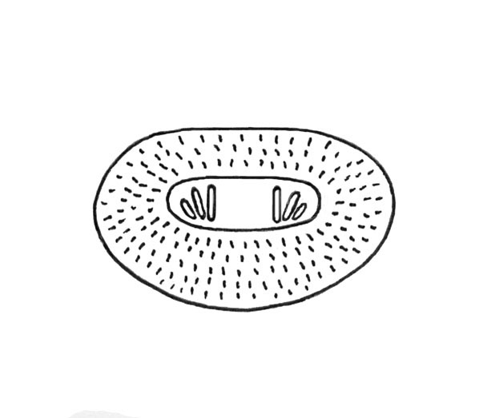

*Dermatobia hominis*

Posterior view of terminal segment to show spiracles.

(Illustration by C. Whitehorn)

*Dermatobia hominis*

Diagram of third instar larva.

(Illustration by C. Whitehorn)

*Oestrus ovis* – the sheep nasal bot-fly

The sheep nasal bot-fly is worldwide in distribution and particularly common where sheep and goats are reared. The female fly deposits live first instar larvae directly on the host with the nasal passages being the primary larviposition site followed by the eyes, mouth and ears. People, especially those working with livestock, may occasionally be attacked. The most common history is a patient who reports being struck in the eye by a small object and who goes on to develop a painful inflammation of the eye in the following few hours. An acute catarrhal conjunctivitis may be diagnosed. In man *Oestrus* is generally non-invasive and the first instar larva is unable to develop further, however it may remain viable for ten days causing discomfort to the patient throughout that period. Larvae need to be removed from the conjunctival sac by an ophthalmologist.

Description

The first instar larvae are very small (1.0mm long), elongate, oval and transparent but the large mouth hooks are particularly distinct and are the diagnostic feature.

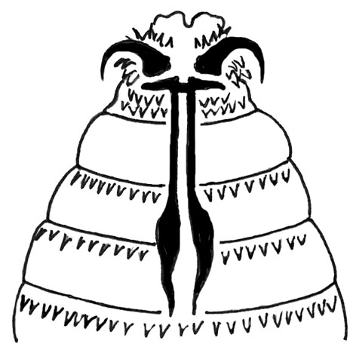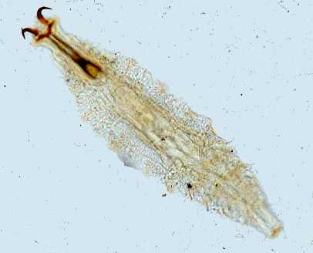

*Oestrus ovis*

Photograph of first instar larva.

© LSHTM

*Oestrus ovis*

Diagram of cephalopharyngeal skeleton of first instar larva.

(Illustration by C. Whitehorn)

The strong buccal hooks are recurved and horn-like and may be withdrawn into the body. Small spines are present on each body segment and the last segment bears two prominences each possessing a number of hooklets.

*Sarcophaga* – flesh flies

The flesh flies are of cosmopolitan distribution. Female flies lay first instar larvae directly on decaying organic matter or faeces and normally attack man only as secondary invaders. The exception is *Wohlfahrtia magnifica* which is an obligate, primary invader. *Sarcophaga* specieshave been recorded infesting the bedsores of elderly patients. Female flies will also deposit larvae on foodstuffs, and if these are ingested an intestinal myiasis may occur.

Description

Maggots of the genus *Sarcophaga* have the classic “maggot” form with a narrow anterior segment bearing the mouth-hooks broadening out to a truncate posterior segment. A mature larva is about 16-22mm long.

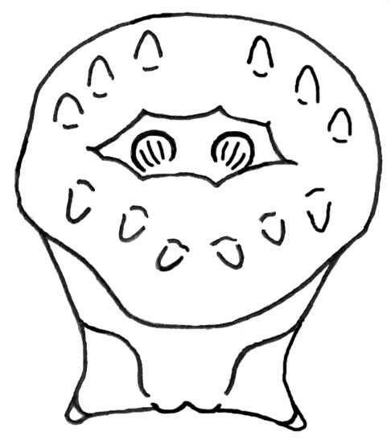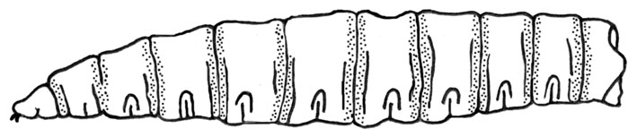

*Sarcophaga* species

Diagram of third instar larva.

(Illustration by C. Whitehorn)

*Sarcophaga* species

Posterior view of terminal segment.

(Illustration by C. Whitehorn)

The posterior spiracles are recessed into a deep cavity on the terminal segment and can be concealed when the cavity is closed. The spiracles themselves consist of three straight slits surrounded by an open peritremal ring with no button.

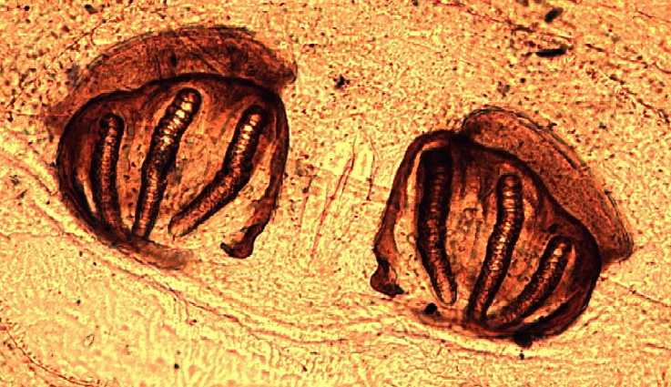

*Sarcophaga* species.

Photograph of posterior spiracles.

© LSHTM

*Sarcophaga* species.

Diagram of the posterior spiracles of third instar larva.

(Illustration by C. Whitehorn)

Leeches

Description

Leeches (Euhirudinea) are hermaphroditic annelids, which feed by sucking blood and tissue fluids from their hosts15-17. Aquatic and terrestrial forms exist.

Aquatic leeches have a worldwide distribution. Terrestrial species are found in South-East Asia, the Pacific islands, the Indian subcontinent, and South America18. Terrestrial leeches inhabiting the tropical rain forests, and attaching to the skin of man and animals, are a great nuisance. However, individual bites of such leeches are generally medically trivial, and are not usually associated with infection, or with transmission of disease, but evidence for persistence of various pathogens within the bodies of leeches has been reported, including blood-borne19.

Iatrogenic wound infection with *Aeromonas* species is described, especially in the context of medicinal use of leeches (principally *Hirudo medicinalis*, but other species have been used20). These leeches have a symbiotic relationship with bacteria of the genus *Aeromonas*, which inhabit their intestine often in pure culture, but other potentially pathogenic bacteria may also be present20-23.

*H. medicinalis* may be applied to reduce tissue engorgement consequent upon plastic surgical or vascular reconstructive manoeuvres. The engorged tissue may be particularly susceptible to infection by *Aeromonas* species.

Once a leech attached to the skin has finished its meal, it will generally detach spontaneously. Bleeding may continue for many minutes or hours, unless staunched by an appropriate dressing (during feeding, an anticoagulant – hirudin - is injected by the leech).

An attached leech should be allowed to feed for a period so that there is a flow of blood out of the wound. This may help to carry away any microbes that may have been introduced to the lesion.

Medicinal leeches must only be subject to single-patient use.

The first indication of a wild leech bite is often the discovery of blood in clothing, the leeches having already fed, engorged and detached. There is controversy on this point, but it is thought desirable by some to cause an attached terrestrial leech to detach, by application to the organism of heat from a burning cigarette or match, or application of a strong solution of salt, or alcohol, rather than simply pulling it off directly, which may leave mouthparts still embedded in the wound18.

Certain South American leeches do not possess jaws, and feed by insertion of a proboscis deep beneath a host’s tissue. Violent removal of these leeches could leave a long tube of leech tissue in the host.

Some of the aquatic (nasopharyngeal) species are capable of causing very serious disease in humans and animals, and sometimes prove fatal. Such leeches are to be found in fresh waters in parts of the Middle East and Africa, the Indian sub-continent, and China.

These leeches are small and thread-like when first hatched, and enter the bodies of drinking animals or humans, or bathers in surface waters, attaching to the mucous tissue in the nasopharyngeal and buccal cavities, occasionally the oesophagus, or the tracheobronchial tree. Leeches may remain attached for several weeks, before emerging fully grown. Growth within the host is dramatic, and one species, *Dinobdella ferox,* may attain a length of 250mm.

Aquatic (nasopharyngeal) leeches may also enter the urethra or vagina in swimmers and bathers, or attach to the conjunctiva.

Obstruction, epistaxis, haemoptysis, haematemesis and severe anaemia may result from attachment of aquatic (nasopharyngeal) leeches. Leeches may be surgically removed – application of cocaine or hypertonic saline to the leech may facilitate detachment of the organism18,24. Tracheostomy may be necessary to gain access, or to relieve life-threatening respiratory obstruction.

Protection

Complete protection against leeches is almost impossible. In tropical climates chemical repellents only work for a limited period due to sweating. Terrestrial leeches are extremely slender, very agile, and are capable of squeezing through boot eyelets, and all but the most tightly woven cloth. However, travellers should ideally wear thick trousers treated with a repellent such as diethyl toluamide, tucked into the tops of stout boots.

Where nasopharyngeal leeches occur, drinking water should be strained through a tight mesh, or preferably boiled.

Swimming or bathing in untreated surface waters overseas is always most unwise, for a variety of reasons.

Use of antibiotic prophylaxis may be indicated if medicinal leeches are to be applied to engorged tissues as a part of post-operative surgical care20. Ciprofloxacin and extended-spectrum beta-lactam agents may be considered for this indication, depending on the antibiotic sensitivity of the *Aeromonas* species that the leech is carrying23,25.

Preservation of specimens

To ensure specimens are suitable for taxonomic anatomy, live leeches should be narcotised in 15% alcohol. When fully narcotised the leeches should be extended flat for fixing in 70% alcohol or 5% formalin. Specimens dropped live to formalin or concentrated alcohol contract violently, harden and are useless for identification.

Technical information/limitations

Limitations of UK SMIs

The recommendations made in UK SMIs are based on evidence (for example, sensitivity and specificity) where available, expert opinion and pragmatism, with consideration also being given to available resources. Laboratories should take account of local requirements and undertake additional investigations where appropriate. Prior to use, laboratories should ensure that all commercial and in-house tests have been validated and are fit for purpose.

Selective media in screening procedures

Selective media which does not support the growth of all circulating strains of organisms may be recommended based on the evidence available. A balance therefore must be sought between available evidence, and available resources required if more than one media plate is used.

Specimen containers26,27

UK SMIs use the term “CE marked leak proof container” to describe containers bearing the CE marking used for the collection and transport of clinical specimens. The requirements for specimen containers are given in the EU in vitro Diagnostic Medical Devices Directive (98/79/EC Annex 1 B 2.1) which states: “The design must allow easy handling and, where necessary, reduce as far as possible contamination of and leakage from, the device during use and, in the case of specimen receptacles, the risk of contamination of the specimen. The manufacturing processes must be appropriate for these purposes”.

1 Safety considerations26-41

1.1 Specimen collection, transport and storage26-31

Personnel should wear gloves, a laboratory coat and work in a well-lit, clear laboratory space.

Containment Level 2 is required for routine work.

In some cases ectoparasites may be engorged with human blood or body tissue, this may pose a risk to the person handling them if infected with a Hazard Group 3 organism. If a Hazard Group 3 organism is suspected, a microbiological safety cabinet at Containment Level 3 is required.

Any specimen contaminated by the body fluids or blood of the patient should be immersed in 10% formol water at a ratio of 1:3 (specimen: formol water) for a minimum of 30 minutes prior to being processed.

Specimens should be handled with forceps or a fine brush. When processing material the use of sterile scissors is recommended in preference to a scalpel blade.

Live specimens should be killed prior to identification unless required live for the isolation of pathogens. Live specimens should be handled with extreme care and chilled in a refrigerator if there is any risk of escape during processing. Live specimens are killed with hot water (85°C) (ticks, lice, fleas, bedbugs, myiasis maggots), or with ethyl acetate (beetles and adult flies) or killed by ethyl acetate vapour. Please refer to the appropriate section for further details.

Some specimens may require a period of clearing in hot 5% potassium hydroxide solution prior to identification, in which case appropriate protective equipment must be worn.

Alcohol and organic solvents such as Euparal should not be used near naked flames and should be used in an area with good ventilation. Solvents should not be used in microbiological safety cabinets as they present an ignition risk and may promote damage to the HEPA filters.

The containers of specimens preserved in alcohol should be tightly sealed and stored in lockable metal cabinets.

Use aseptic technique.

Collect specimens in appropriate CE marked leak proof containers and transport in sealed plastic bags.

Compliance with postal, transport and storage regulations is essential.

1.2 Specimen processing26-41

Specimens should be handled with care using forceps or a fine brush to avoid damage to taxonomic features required for identification.

Specimens that have been stored in formalin or washed in formol water may toughen and be more difficult to process. It is recommended that they are transferred in to 70% ethanol as soon as possible.

Some flea specimens may require a period of clearing prior to examination. The immersion of specimens in 5% KOH for several days is normally adequate.

Containment Level 2.

Laboratory procedures that give rise to infectious aerosols must be conducted in a microbiological safety cabinet34.

Refer to current guidance on the safe handling of all organisms documented in this UK SMI.

The above guidance should be supplemented with local COSHH and risk assessments.

2 Specimen collection

2.1 Type of specimens

Ectoparasitic arthropods, leeches

2.2 Optimal time and method of collection42

Specimens should be handled with care to avoid damage to taxonomic features required for identification. Specimens should be collected directly from the patient whenever possible or from the environment in which the patient lives. Specimens should be collected into a CE marked leak proof containerin a sealed plastic bag26.

Ideally specimens should be killed before postage. All soft-bodied specimens (lice, fleas, bedbugs, ticks and fly larvae) should be killed by immersion in hot water, transferred to and transported in 70% ethanol. All hard bodied specimens (including beetles and adult flies) should be killed by exposure to ethyl acetate vapour and transported dry. Mites may be killed and transported in 70% ethanol. Refer to the appropriate section for further details. A short patient history and details of any foreign travel should be included.

Inner packaging containing the specimen should be examined prior to opening to ascertain if the insect/arachnid is still living. Living specimens should be killed with hot water or ethyl acetate vapour prior to examination. Where there is a risk that live specimens may escape when the container is opened, they should be chilled in a refrigerator before processing.

To ensure specimens are suitable for taxonomic anatomy live leeches should be narcotised in 15% ethanol. When fully narcotised the leeches should be extended flat for fixing in 70% ethanol or 5% formalin. Specimens dropped live to formalin or concentrated ethanol contract violently, harden and are useless for identification.

For safety considerations refer to Section 1.1.

Collect specimens before starting treatment where possible42.

Collect specimens into appropriate CE marked leak proof containers and place in sealed plastic bags.

2.3 Adequate quantity and appropriate number of specimens42

Numbers and frequency of specimens collected are dependent on clinical condition of patient.

3 Specimen transport, storage and retention26,27

3.1 Optimal transport and storage conditions

For safety considerations refer to Section 1.1.

Specimens should be transported and processed as soon as possible42.

If processing is delayed, refrigeration is preferable to storage at ambient temperature42.

Samples should be retained in accordance with The Royal College of Pathologists guidelines ‘The retention and storage of pathological records and specimens’43.

4 Specimen processing/procedure26,27

4.1 Test selection

N/A

4.2 Appearance

N/A

4.3 Sample preparation

For safety considerations refer to Section 1.2.

4.4 Microscopy

4.4.1 Standard

N/A

4.4.2 Supplementary / Preparation of smears

N/A

4.5 Culture and investigation

N/A

4.6 Identification

N/A

4.7 Antimicrobial susceptibility testing

N/A

4.8 Referral for outbreak investigations

N/A

4.9 Referral to reference laboratories

The ectoparasites covered by this UK SMI are rare laboratory specimens in the UK and where appropriate should be forwarded to a reference laboratory for confirmation.

Contact appropriate devolved national reference laboratory for information on the tests available, turnaround times, transport procedure and any other requirements for sample submission:

**England and Wales**

<https://www.gov.uk/specialist-and-reference-microbiology-laboratory-tests-and-services>

**London**

The Diagnostic Parasitology Laboratory

London School of Hygiene and Tropical Medicine

Keppel Street

London, WC1E 7HT

**OR**

If in the Hays DX scheme:

PHE Malaria Reference Laboratory

DX 6641200

Tottenham Court Rd 92WC

**Liverpool**

The Clinical Diagnostic Parasitology Laboratory   
Liverpool School of Tropical Medicine   
Pembroke Place   
Liverpool  
L3 5QA

**OR**

If in the Hays DX scheme:

Liverpool School of Tropical Medicine  
Diagnostic Laboratory  
DX 6966301  
Liverpool 92L

**Scotland**

<http://www.hps.scot.nhs.uk/reflab/index.aspx>

Glasgow

Scottish Microbiology Reference Laboratories

Glasgow Scottish Parasite Diagnostic and Reference Section

Level 5

New Lister Building

Glasgow Royal Infirmary

Alexandra Parade

Glasgow

G31 2ER

**Northern Ireland**

<http://www.belfasttrust.hscni.net/Laboratory-MortuaryServices.htm>

For information on the tests offered, turnaround times, transport procedure and the other requirements of the reference laboratory [click here for user manuals and request forms](https://www.gov.uk/specialist-and-reference-microbiology-laboratory-tests-and-services).

Organisms with unusual or unexpected resistance, or associated with a laboratory or clinical problem, or anomaly that requires elucidation should be sent to the appropriate reference laboratory.

Contact appropriate devolved national reference laboratory for information on the tests available, turnaround times, transport procedure and any other requirements for sample submission:

England and Wales

<https://www.gov.uk/specialist-and-reference-microbiology-laboratory-tests-and-services>

Scotland

<http://www.hps.scot.nhs.uk/reflab/index.aspx>

Northern Ireland

<http://www.publichealth.hscni.net/directorate-public-health/health-protection>

5 Reporting procedure

5.1 Microscopy

5.1.1 Microscopy reporting time

All results should be issued to the requesting clinician as soon as they become available, unless specific alternative arrangements have been made with the requestors.

Urgent results should be telephoned or transmitted electronically in accordance with local policies.

5.2 Culture

N/A

5.3 Antimicrobial susceptibility testing

Report susceptibilities as clinically indicated. Prudent use of antimicrobials according to local and national protocols is recommended.

6 Notification to PHE44,45, or equivalent in the devolved administrations46-49

The Health Protection (Notification) regulations 2010 require diagnostic laboratories to notify Public Health England (PHE) when they identify the causative agents that are listed in Schedule 2 of the Regulations. Notifications must be provided in writing, on paper or electronically, within seven days. Urgent cases should be notified orally and as soon as possible, recommended within 24 hours. These should be followed up by written notification within seven days.

For the purposes of the Notification Regulations, the recipient of laboratory notifications is the local PHE Health Protection Team. If a case has already been notified by a registered medical practitioner, the diagnostic laboratory is still required to notify the case if they identify any evidence of an infection caused by a notifiable causative agent.

Notification under the Health Protection (Notification) Regulations 2010 does not replace voluntary reporting to PHE. The vast majority of NHS laboratories voluntarily report a wide range of laboratory diagnoses of causative agents to PHE and many PHE Health protection Teams have agreements with local laboratories for urgent reporting of some infections. This should continue.

**Note:** The Health Protection Legislation Guidance (2010) includes reporting of Human Immunodeficiency Virus (HIV) & Sexually Transmitted Infections (STIs), Healthcare Associated Infections (HCAIs) and Creutzfeldt–Jakob disease (CJD) under ‘Notification Duties of Registered Medical Practitioners’: it is not noted under ‘Notification Duties of Diagnostic Laboratories’.

<https://www.gov.uk/government/organisations/public-health-england/about/our-governance#health-protection-regulations-2010>

Other arrangements exist in [Scotland](http://www.scotland.gov.uk/Topics/Health/Policy/Public-Health-Act/Implementation/Guidance/Guidance-Part2)46,47, [Wales](http://www.wales.nhs.uk/sites3/page.cfm?orgid=457&pid=48544)48 and [Northern Ireland](http://www.publichealth.hscni.net/directorate-public-health/health-protection)49.

References

**Modified GRADE table used by UK SMIs when assessing references**

Grading of Recommendations, Assessment, Development, and Evaluation (GRADE) is a systematic approach to assessing references. A modified GRADE method is used in UK SMIs for appraising references for inclusion. Each reference is assessed and allocated a grade for strength of recommendation (A-D) and quality of the underlying evidence (I-VI). A summary table which defines the grade is listed below and should be used in conjunction with the reference list.

|  |  |
| --- | --- |
| **Strength of recommendation** | **Quality of evidence** |
| A Strongly recommended | I Evidence from randomised controlled trials, meta-analysis and systematic reviews |
| B Recommended but other alternatives may be acceptable | II Evidence from non-randomised studies |
| C Weakly recommended: seek alternatives | III Non-analytical studies, for example, case reports, reviews, case series |
| D Never recommended | IV Expert opinion and wide acceptance as good practice but with no study evidence |
|  | V Required by legislation, code of practice or national standard |
|  | VI Letter or other |

1. Medical Insects and Arachnids. In: Lane RP, Crosskey RW, editors: Kluwer Academic Publishers; 1993.

2. Mathison BA, Pritt BS. Laboratory identification of arthropod ectoparasites. ClinMicrobiolRev 2014;27:48-67.

3. Nordlund JJ. Cutaneous ectoparasites. DermatolTher 2009;22:503-17.

4. Sassera D, Epis S, Pajoro M, Bandi C. Microbial symbiosis and the control of vector-borne pathogens in tsetse flies, human lice, and triatomine bugs. PathogGlobHealth 2013;107:285-92.

5. Nuttall GHF. The biology of Pediculus humanus. 10 ed.; 1917. p. 80-186.

6. Nuttall GHF. The biology of Phthirus pubis. 10 ed.; 1918. p. 383-406.

7. Insects and Hygiene: the Biology and Control of Insect Pests of Medical and Domestic Importance. 3rd ed.: Chapman and Hall; 1980.

8. Boase CJ. Bed-bugs - reclaiming our cities. Biologist 2004;51:9-12.

9. The Natural History Museum Mites and Ticks of Domestic Animals: an Identification Guide and Information Source: The Stationary Office Books; 1999.

10. Arthur DR. British ticks. London: Butterworths; 1963. p. 33-65.

11. Ticks of North-west Europe (Synopses of the British Faunas): Backhuys Publishers; 1996.

12. British Infection Association. The epidemiology, prevention, investigation and treatment of Lyme borreliosis in United Kingdom patients: a position statement by the British Infection Association. JInfect 2011;62:329-38.

13. James MT. The Flies that Cause Myiasis in Man (Miscellaneous Publication no. 631 - United States Dept. of Agriculture). U.S. Govt. Printing Office 1947.

14. Myiasis in Man and Animals in the Old World: Butterworth and Company Limited; 1965.

15. Leech Biology and Behaviour: Anatomy, Physiology and Behaviour Vol 1: Oxford University Press; 1986.

16. Leech Biology and Behaviour: Feeding, Biology, Ecology and Systematics Vol 2: Oxford University Press; 1986.

17. Leech Biology and Behaviour: Bibliography Vol 3: Oxford University Press; 1986.

18. White GB. Ectoparasites: Leeches and leech infestation, myiasis, jigger fleas, scabies, louse infestation. In: Cook GC, Zumla A, editors. Manson's Tropical Diseases. 21st ed. Edinburgh: WB Saunders Company; 2003. p. 1599-600.

19. Nehili M, Ilk C, Mehlhorn H, Ruhnau K, Dick W, Njayou M. Experiments on the possible role of leeches as vectors of animal and human pathogens: a light and electron microscopy study. ParasitolRes 1994;80:277-90.

20. Mackay DR, Manders EK, Saggers GC, Banducci DR, Prinsloo J, Klugman K. Aeromonas species isolated from medicinal leeches. AnnPlastSurg 1999;42:275-9.

21. Indergand S, Graf J. Ingested blood contributes to the specificity of the symbiosis of Aeromonas veronii biovar sobria and Hirudo medicinalis, the medicinal leech. ApplEnvironMicrobiol 2000;66:4735-41.

22. Graf J. Symbiosis of Aeromonas and Hirudo medicinalis, the medical leech. American Society for Microbiology News 2000;66:147-53.

23. Nonomura H, Kato N, Ohno Y, Itokazu M, Matsunaga T, Watanabe K. Indigenous bacterial flora of medicinal leeches and their susceptibilities to 15 antimicrobial agents. JMedMicrobiol 1996;45:490-3.

24. Cundall DB, Whitehead SM, Hechtel FO. Severe anaemia and death due to the pharyngeal leech Myxobdella africana. TransRSocTropMed Hyg 1986;80:940-4.

25. Fenollar F, Fournier PE, Legre R. Unusual case of Aeromonas sobria cellulitis associated with the use of leeches. E J Clin Microbiol Infect Dis 1999;18:72-3.

26. European Parliament. UK Standards for Microbiology Investigations (UK SMIs) use the term "CE marked leak proof container" to describe containers bearing the CE marking used for the collection and transport of clinical specimens. The requirements for specimen containers are given in the EU in vitro Diagnostic Medical Devices Directive (98/79/EC Annex 1 B 2.1) which states: "The design must allow easy handling and, where necessary, reduce as far as possible contamination of, and leakage from, the device during use and, in the case of specimen receptacles, the risk of contamination of the specimen. The manufacturing processes must be appropriate for these purposes". 1998.

27. Official Journal of the European Communities. Directive 98/79/EC of the European Parliament and of the Council of 27 October 1998 on *in vitro* diagnostic medical devices 1998. 1-37.

28. Health and Safety Executive. Safe use of pneumatic air tube transport systems for pathology specimens. 2009.

29. Department for Transport. Transport of Infectious Substances, 2011 Revision 5. 2011.

30. World Health Organization. Guidance on regulations for the Transport of Infectious Substances 2017-2018. 2017.

31. Home Office. Anti-terrorism, Crime and Security Act. 2001.

32. Advisory Committee on Dangerous Pathogens. The Approved List of Biological Agents. Health and Safety Executive 2013. 1-35.

33. Advisory Committee on Dangerous Pathogens. Infections at work: Controlling the risks. Her Majesty's Stationery Office 2003.

34. Advisory Committee on Dangerous Pathogens. Biological agents: Managing the risks in laboratories and healthcare premises. Health and Safety Executive 2005.

35. Advisory Committee on Dangerous Pathogens. Biological Agents: Managing the Risks in Laboratories and Healthcare Premises. Appendix 1.2 Transport of Infectious Substances - Revision. Health and Safety Executive 2008.

36. Centers for Disease Control and Prevention. Guidelines for Safe Work Practices in Human and Animal Medical Diagnostic Laboratories. MMWR Surveill Summ 2012;61:1-102.

37. Health and Safety Executive. Five Steps to Risk Assessment: A Step by Step Guide to a Safer and Healthier Workplace. HSE Books,. 2002.

38. Health and Safety Executive. A Guide to Risk Assessment Requirements: Common Provisions in Health and Safety Law. HSE Books,. 2002.

39. Health Services Advisory Committee. Safe Working and the Prevention of Infection in Clinical Laboratories and Similar Facilities. HSE Books 2003.

40. British Standards Institution (BSI). BS EN12469 - Biotechnology - performance criteria for microbiological safety cabinets 2000.

41. British Standards Institution (BSI). BS 5726:2005 - Microbiological safety cabinets. Information to be supplied by the purchaser and to the vendor and to the installer, and siting and use of cabinets. Recommendations and guidance. 2005. 1-14.

42. Baron EJ, Miller JM, Weinstein MP, Richter SS, Gilligan PH, Thomson RB, Jr. et al. A Guide to Utilization of the Microbiology Laboratory for Diagnosis of Infectious Diseases: 2013 Recommendations by the Infectious Diseases Society of America (IDSA) and the American Society for Microbiology (ASM). ClinInfectDis 2013;57:e22-e121.

43. The Royal College of Pathologists. The retention and storage of pathological records and specimens (5th edition). 1-59. 2015.

44. Public Health England. Laboratory Reporting to Public Health England: A Guide for Diagnostic Laboratories. Public Health England 2016. 1-29.

45. Department of Health. Health Protection Legislation (England) Guidance. 1-112. 2010.

46. Scottish Government. Public Health (Scotland) Act. 2008.

47. Scottish Government. Public Health etc. (Scotland) Act 2008. Implementation of Part 2: Notifiable Diseases, Organisms and Health Risk States. 2009.

48. The Welsh Assembly Government. Health Protection Legislation (Wales) Guidance. 2010.

49. Home Office. Public Health Act (Northern Ireland) 1967 Chapter 36. 1967.

1. # Microbiology is used as a generic term to include the two GMC-recognised specialties of Medical Microbiology (which includes Bacteriology, Mycology and Parasitology) and Medical Virology.